**Food Connect : To Supply Leftover Food to Poor**

Name: Tanisha Agrawal  
Mail Id: <agrawaltanisha141@gmail.com>

College Name: Lakshmi Narain College of Technology & Science  
Trailhead URL: https://www.salesforce.com/trailblazer/tanishaagrawal

## 1.Salesforce Developer Account creation

### 1.1Created Developer Account

Created a developer org in salesforce.

1. Go to <https://developer.salesforce.com/signup>
2. On the sign-up form, enter the following details:
3. First Name: Tanisha
4. Last Name: Agrawal
5. Email: agrawaltanisha141@gmail.com
6. Role: developer
7. Country: India
8. State: Madhya Pradesh
9. Postal Code: 462003
10. Username: admin@airtel1.com
11. Password:Tanisha@9999 [ if you want to verify]

### Account Activation

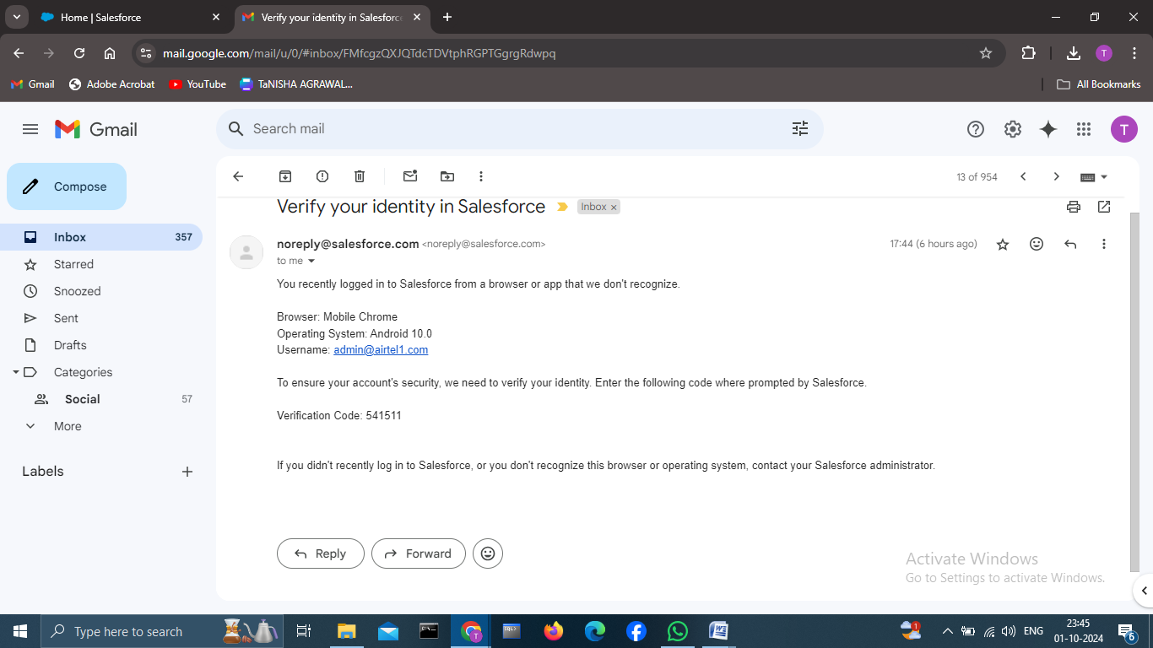

## 2.Object

### 2.1 Created Venue Object

To create an object:

1. From the setup page >> Click on Object Manager >> Click on Create >>Click on Custom Object.
2. Enter the label name >> Venue
3. Plural label name >> Venues
4. Enter Record Name Label and Format

* Record Name >> Venue Name
* Data Type >> Text

1. Click on Allow reports and Track Field History, Allow Activities.
2. Allow search >> Save.

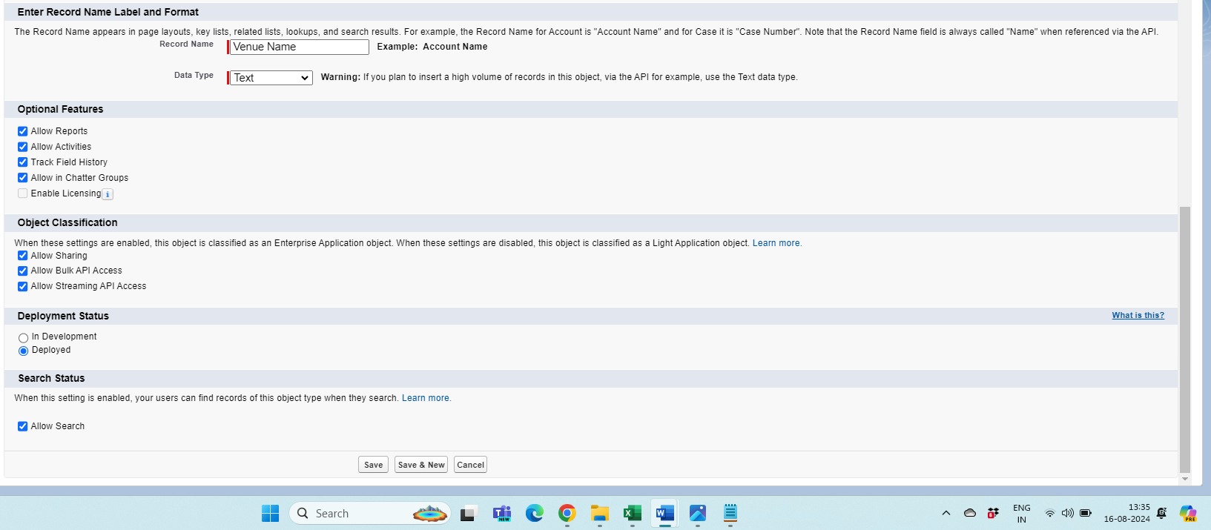

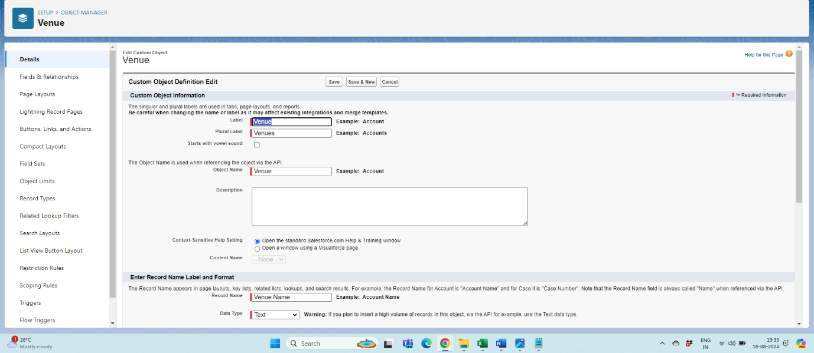

### 2.2 Created Drop-Off Point Object

To create an object:

1. From the setup page >> Click on Object Manager >> Click on Create >> Click on Custom Object.
2. Enter the label name >> Drop-Off Point
3. Plural label name>> Drop-Off Points
4. Enter Record Name Label and Format

* Record Name >> Drop-Off point Name
* Data Type >> Text

1. Click on Allow reports and Track Field History, Allow Activities
2. Allow search >> Save.

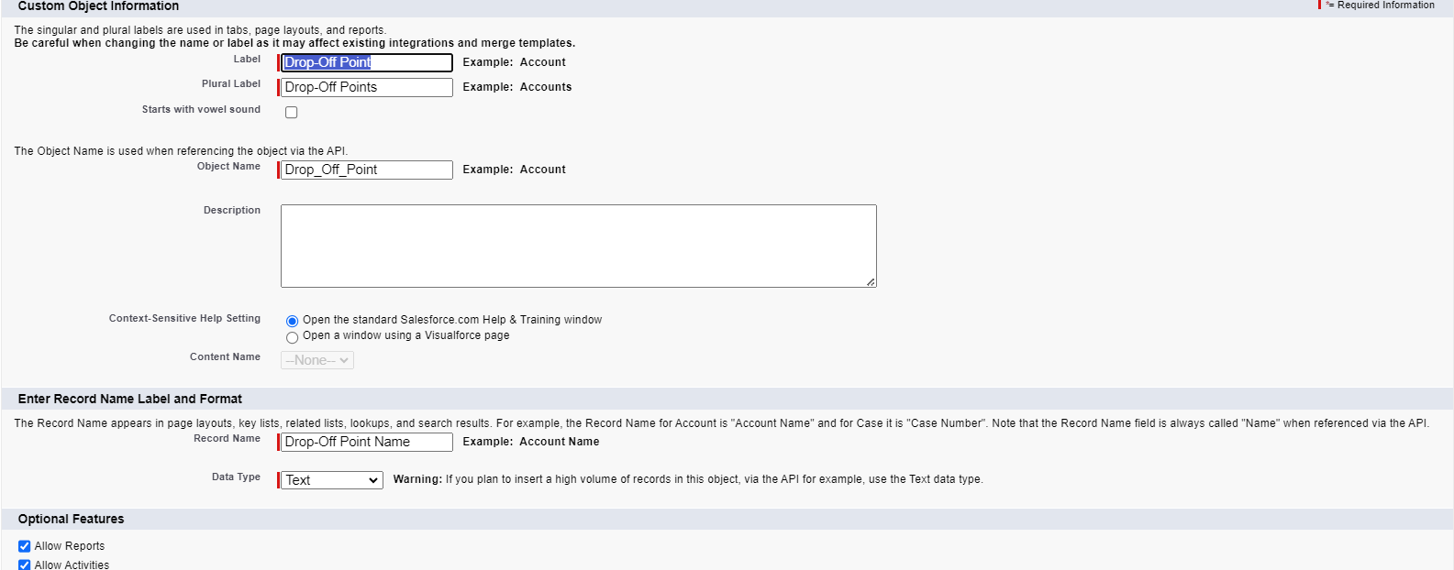

### 2.3 Created Task Object

To create an object:

1. From the setup page >> Click on Object Manager >> Click on Create >> Click on Custom Object.
2. Enter the label name>> Task
3. Plural label name>> Tasks
4. Enter Record Name Label and Format

* Record Name >> Task Name
* Data Type >> Text

1. Click on Allow reports and Track Field History, Allow Activities
2. Allow search >> Save.

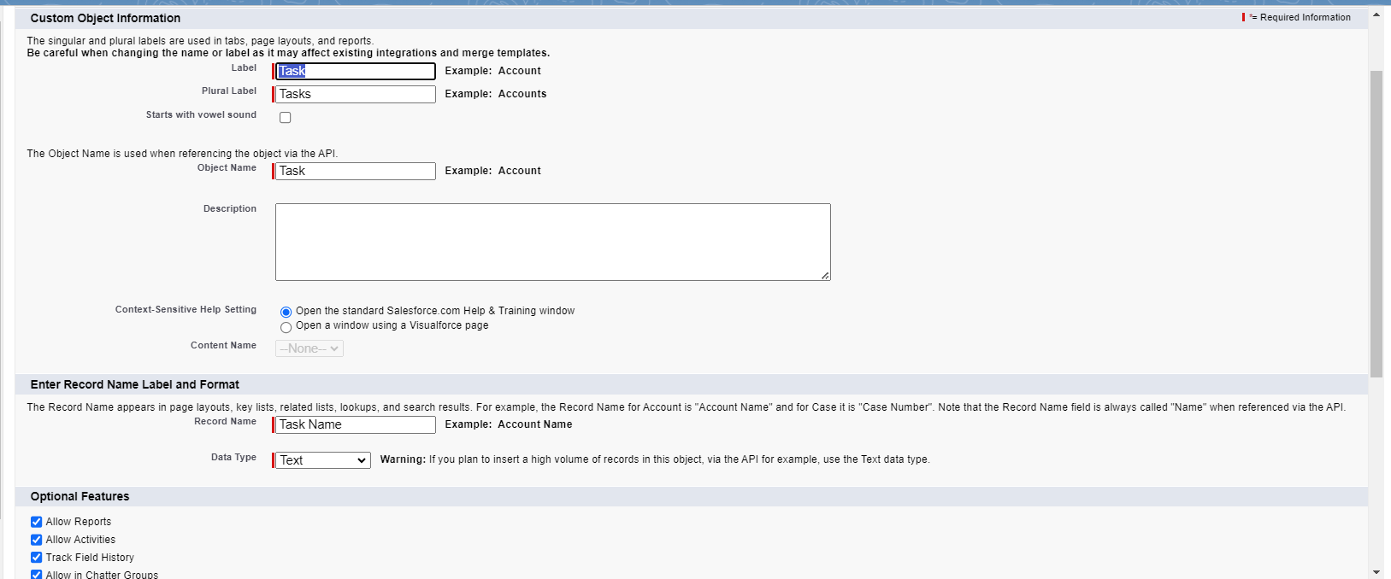

### 2.4 Created Volunteer Object

To create an object:

1. From the setup page >> Click on Object Manager>> Click on Create >> Click on Custom Object.
2. Enter the label name>> Volunteer
3. Plural label name>> Volunteers
4. Enter Record Name Label and Format

* Record Name >> Volunteer Name
* Data Type >> Text

1. Click on Allow reports and Track Field History, Allow Activities
2. Allow search >> Save.

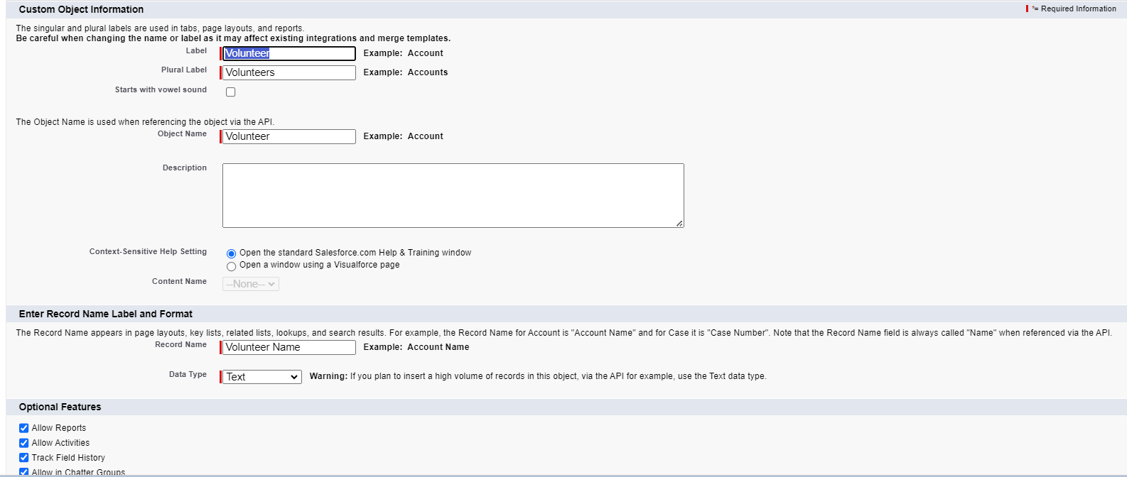

### 2.5 Created Execution Details Object

To create an object:

1. From the setup page >> Click on Object Manager >> Click on Create >> Click on Custom Object.
2. Enter the label name >> Execution Detail
3. Plural label name >> Execution Details
4. Enter Record Name Label and Format

* Record Name >> Execution Detail Name
* Data Type >> Text

1. Click on Allow reports and Track Field History, Allow Activities
2. Allow search >> Save.

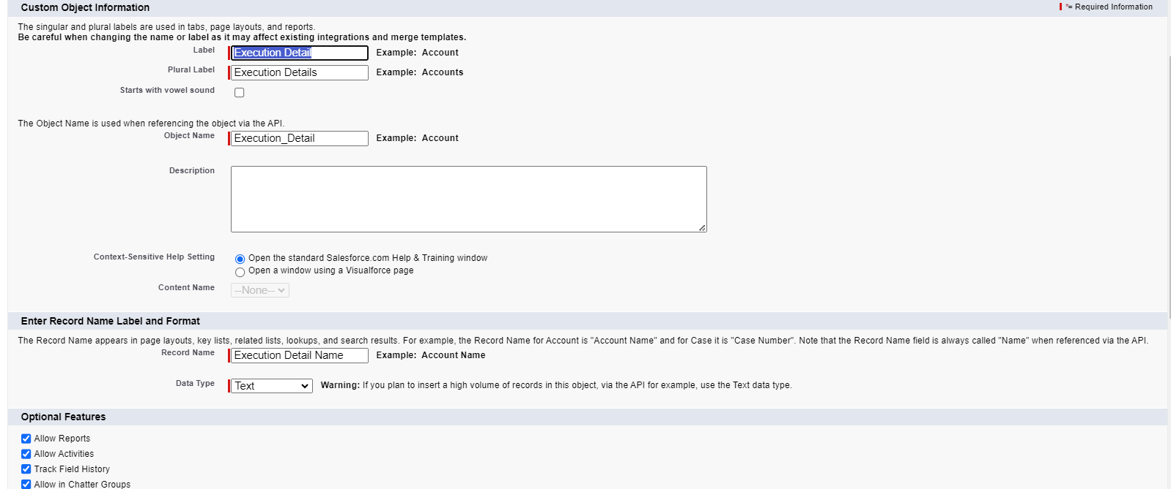

## 3.Tabs

A tab is like a user interface that is used to build records for objects and to view the records in the objects.

**3.1 Creating A Custom Tab**

To create a Tab:(Venue)

1. Go to setup page >> type Tabs in Quick Find bar >> click on tabs >> New (under custom object tab)

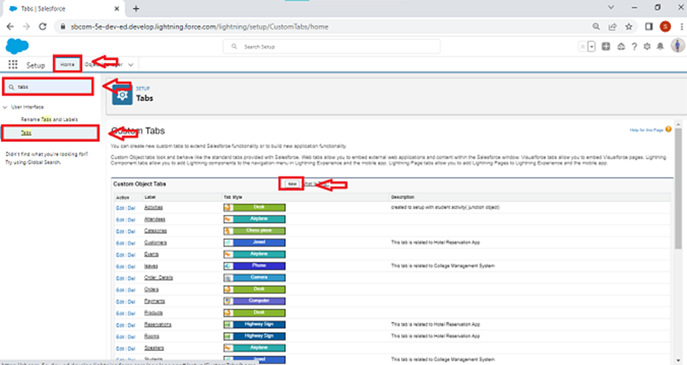

1. Select Object (Venue) >> Select the tab style >> Next (Add to profiles page) keep it as default >> Next (Add to Custom App) uncheck the include tab.
2. Make sure that the Append tab to users' existing personal customizations is checked.
3. Click save

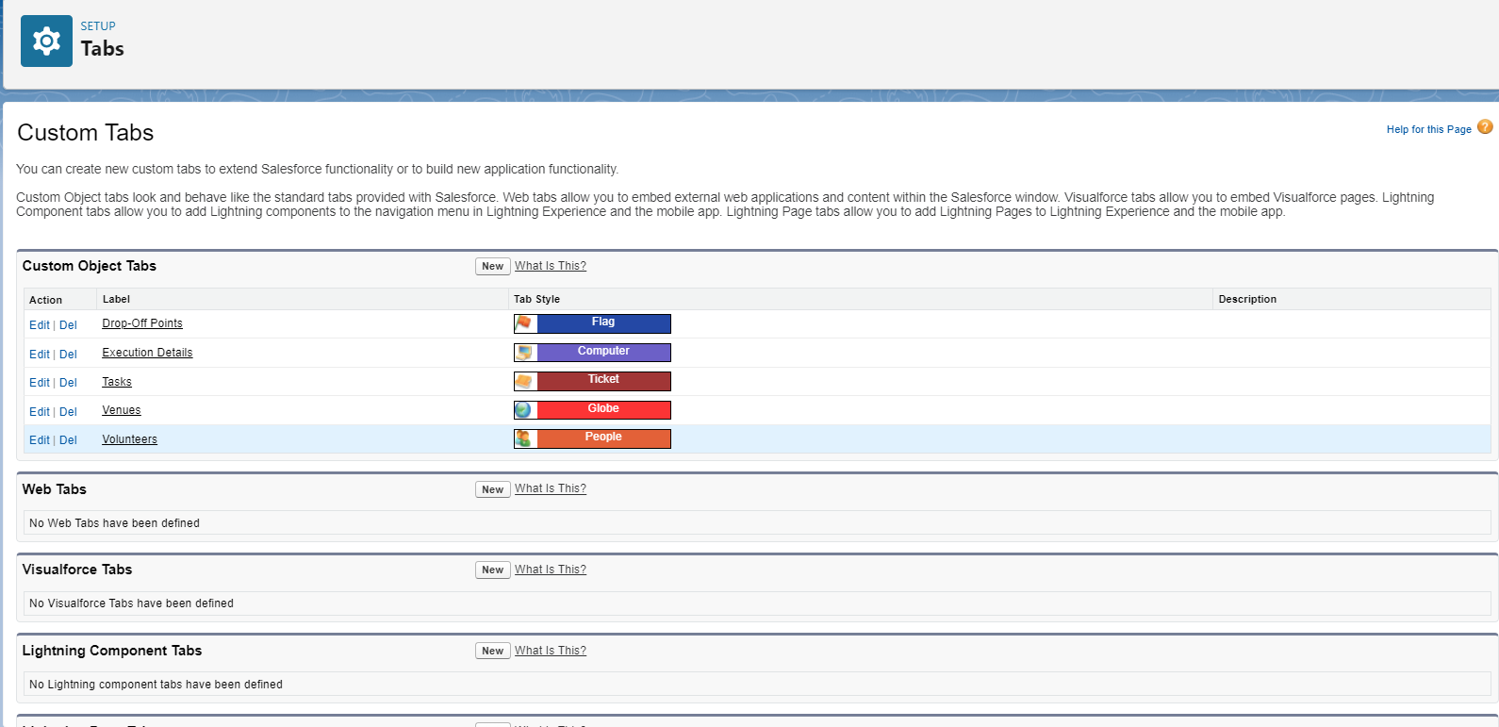

**3.2 Created custom tabs**

With the help of above instructions, I created 5 custom tabs for 5 objects I created before: Venue, Drop-Off point, Task, Volunteer, Execution details.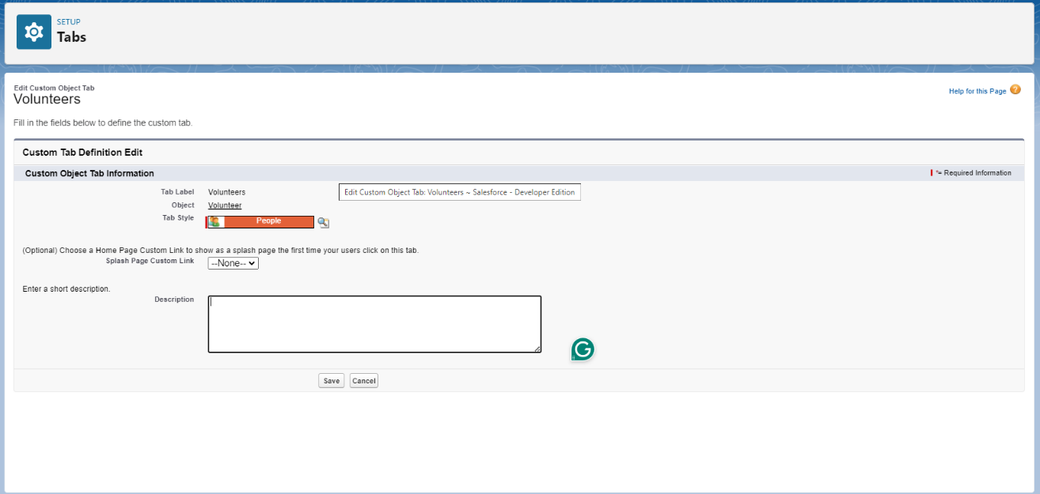

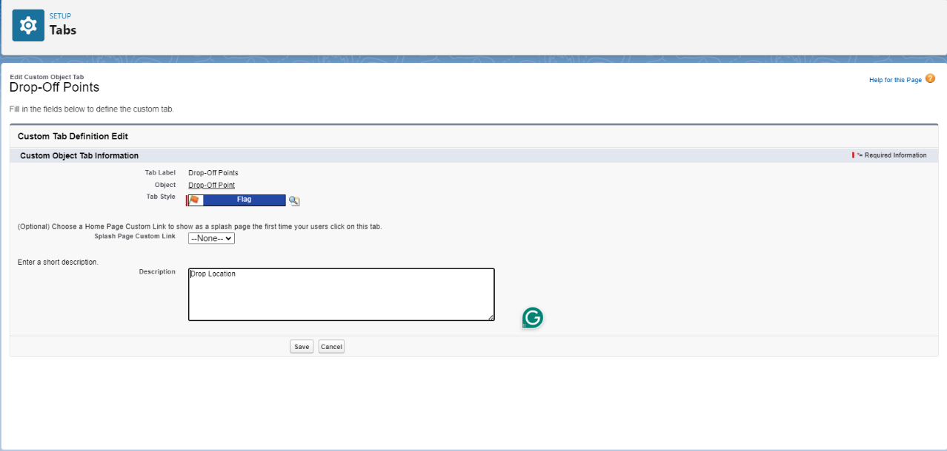

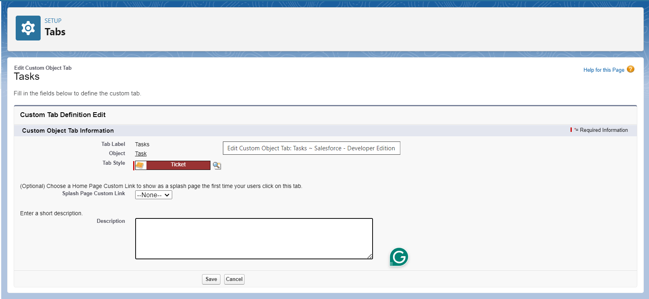

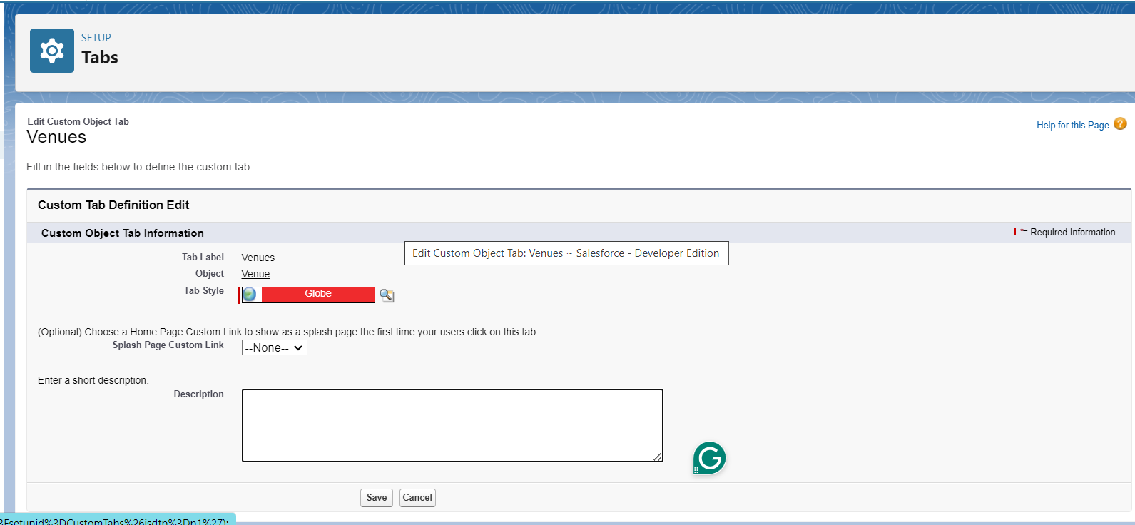



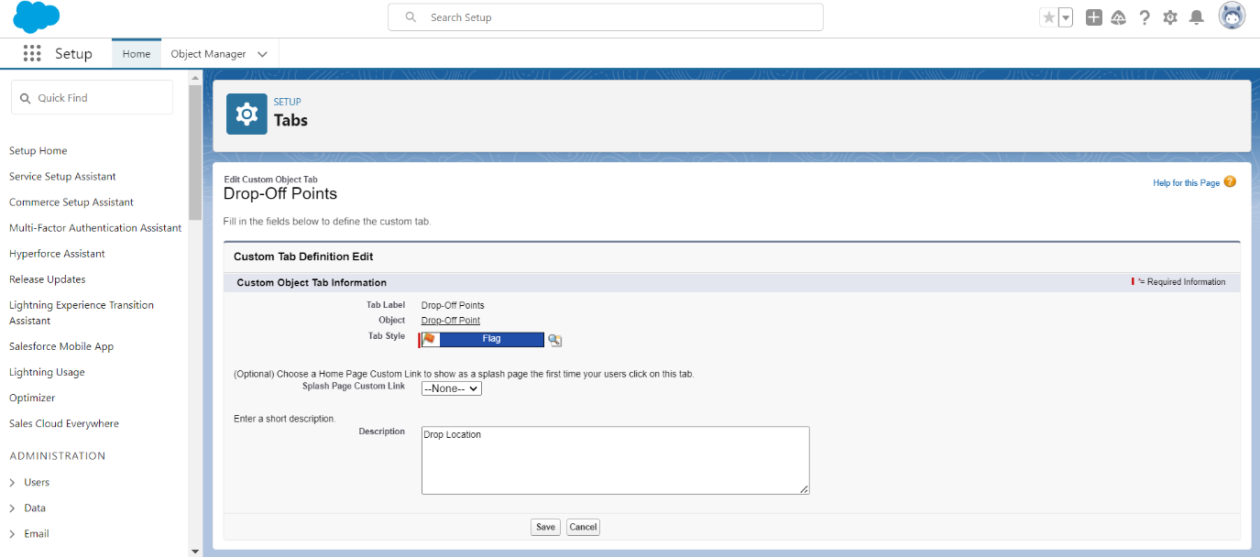

## 4.The Lightning App

### 4.1 Created A Lightning App

**To create a lightning app page:**

1. Go to setup page >> search “app manager” in quick find >> select “app manager” >> click on new lightning App.

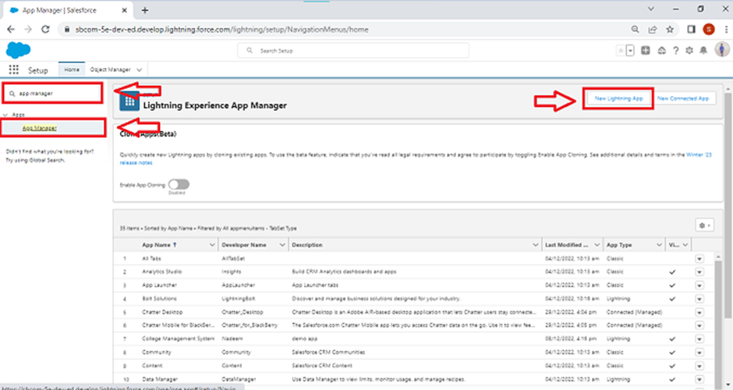

2. Fill the app name in app details and branding as follow  
App Name: FoodConnect  
Developer Name: This will auto populated  
Image: optional (if you want to give any image you can otherwise not mandatory) Primary colour hex value: keep this default.

3.Then click Next >> (App option page) Set Navigation Style as Standard Navigation >> Next.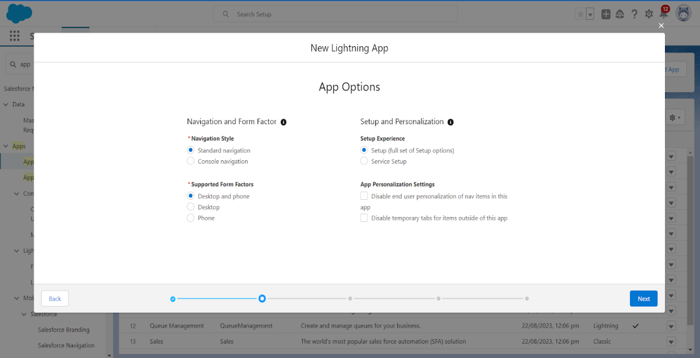

4. (Utility Items) keep it as default >> Next.  
5. To Add Navigation Items:

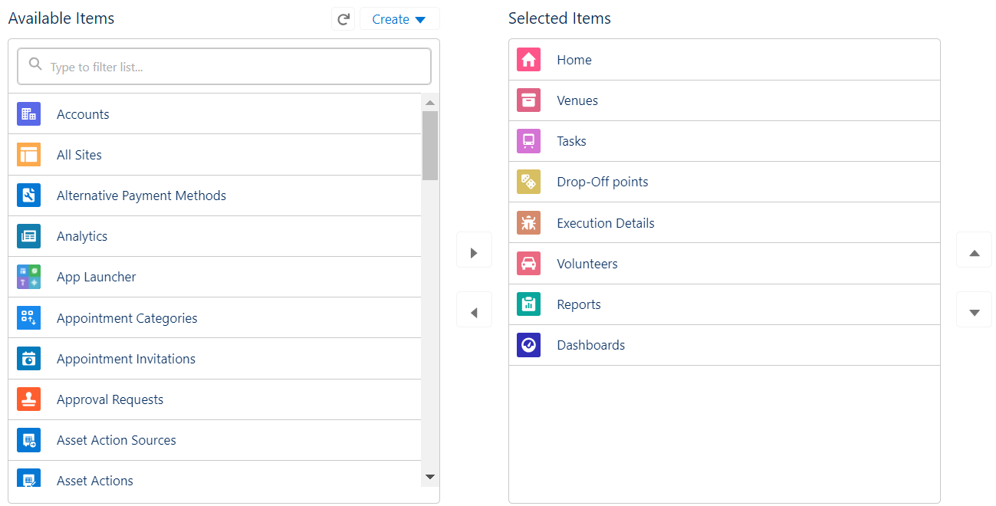

Search for the item in the (Home, Venue, Drop-Off Point, Task, Volunteer, Execution Details, Reports) from the search bar and move it using the arrow button >> Next >> Next.

6. To Add User Profiles:

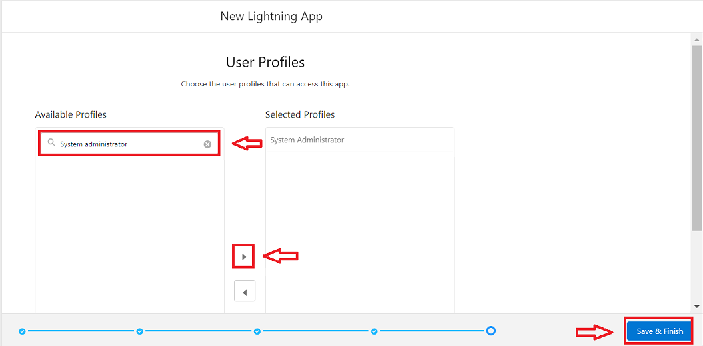

Search profiles (System administrator) in the search bar >> click on the arrow button >> save & finish.

### 4.2 Using above instructions, I created the app

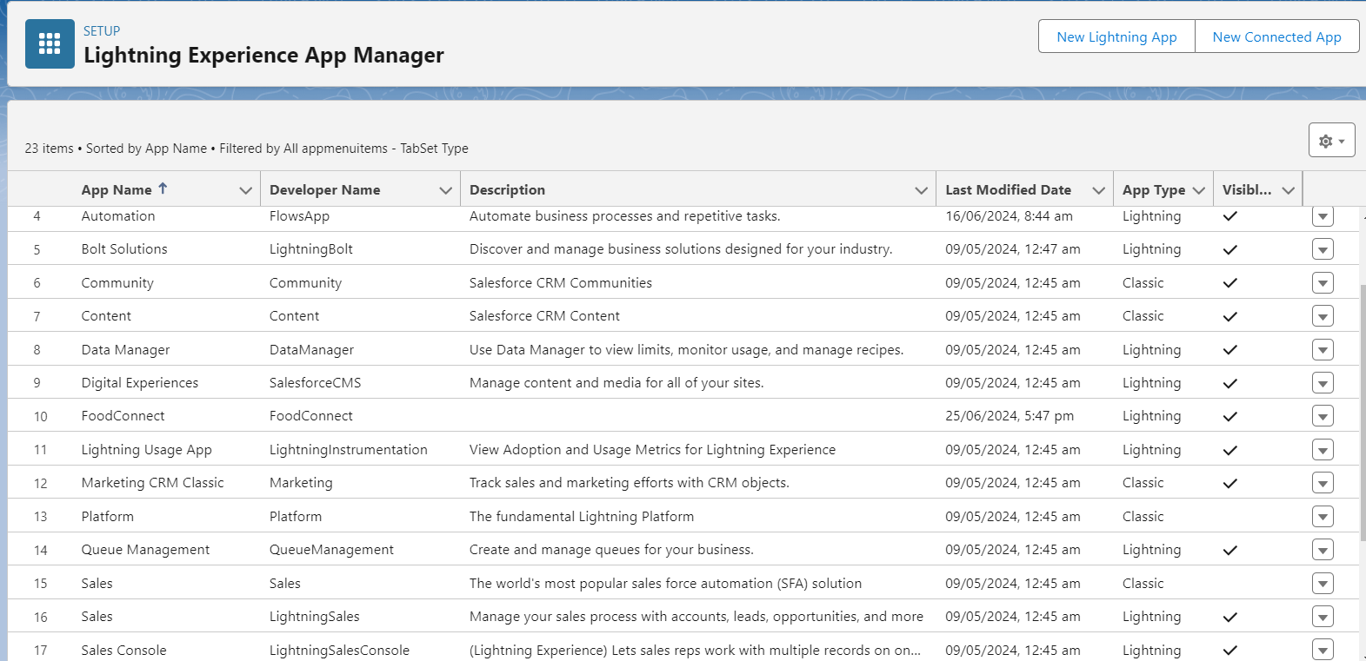

**At Number 10 you can see the app “FoodConnect“ in the above picture.**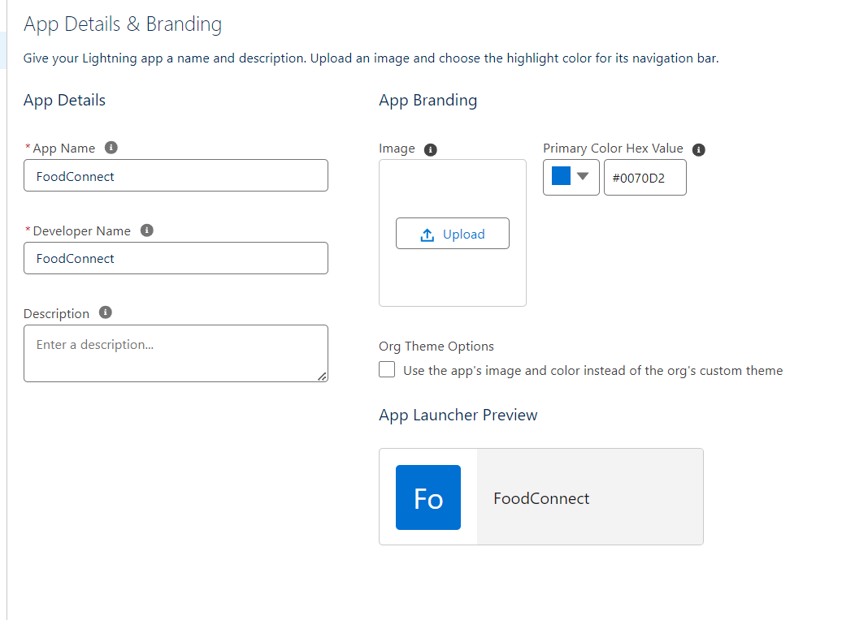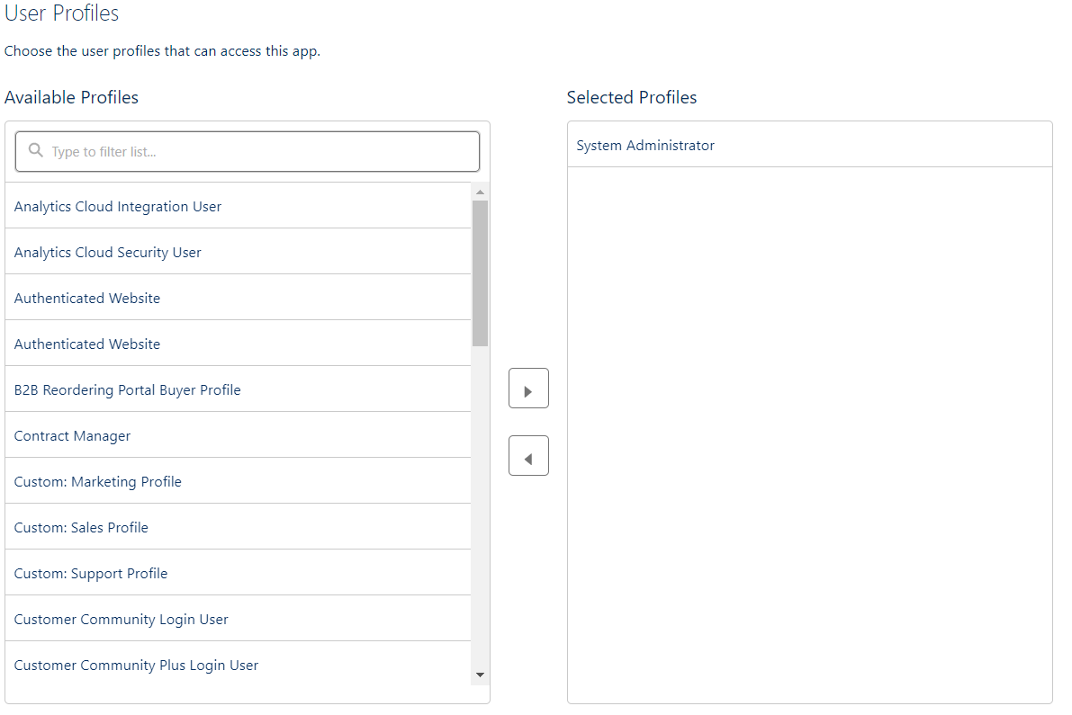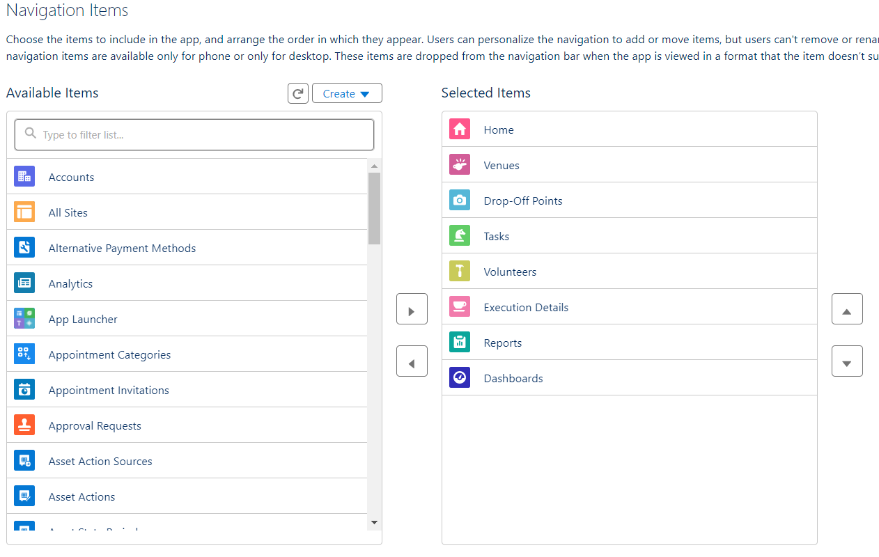

## 5.Fields

**5.1 Creation of Relationship Fields in Objects**

* + 1. **Creation of Lookup Relationship Field on Volunteer Object:**

1. Go to setup >> click on Object Manager >> type object name (Volunteer) in the search bar >> click on the object.

1. Now click on “Fields & Relationships” >> New
2. Select Master Detail relationship
3. Select the related object “Drop-Off point” and click next.
4. Field Name: Drop_Off_point
5. Field label: Auto generated
6. Next >> Next >> Save.

Created the field as per the above instructions and you can observe all the details in the below image:

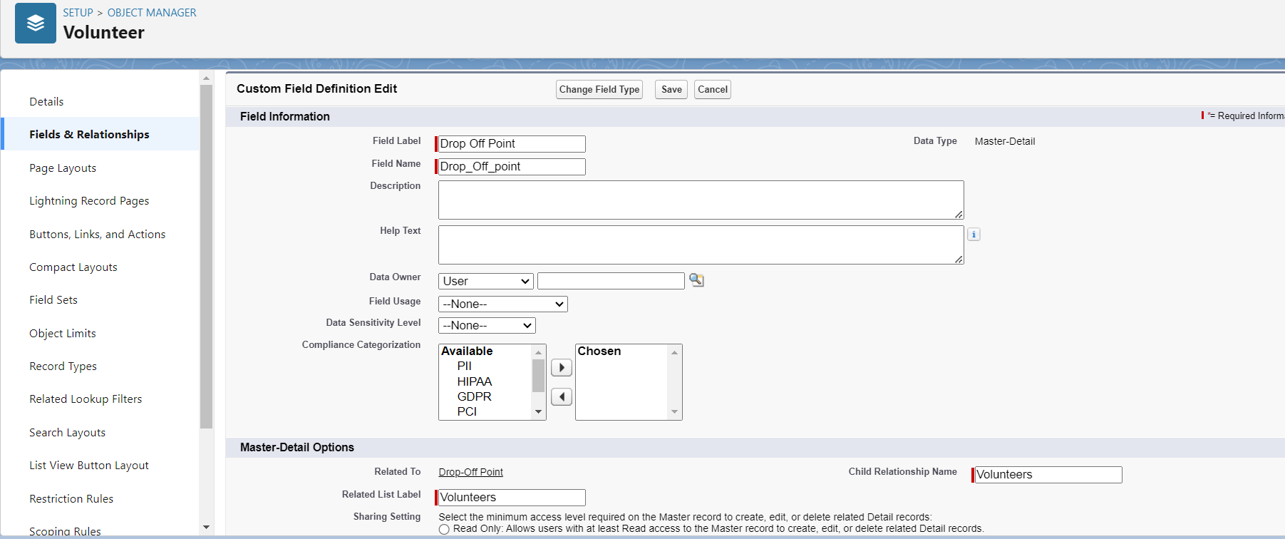

**5.1.2 Creation of Master Detail Relationship Field on Execution Details Object:**

1. Go to setup >> click on Object Manager >> type object name (Execution Details) in the search bar >> click on the object.
2. Now click on “Fields & Relationships” >> New
3. Select Master Detail relationship
4. Select the related object “Volunteer” and click next.
5. Field Name: Volunteer
6. Field label: Auto generated
7. Next >> Next >> Save.

Created the field as per the above instructions and you can observe all the details in the below image:

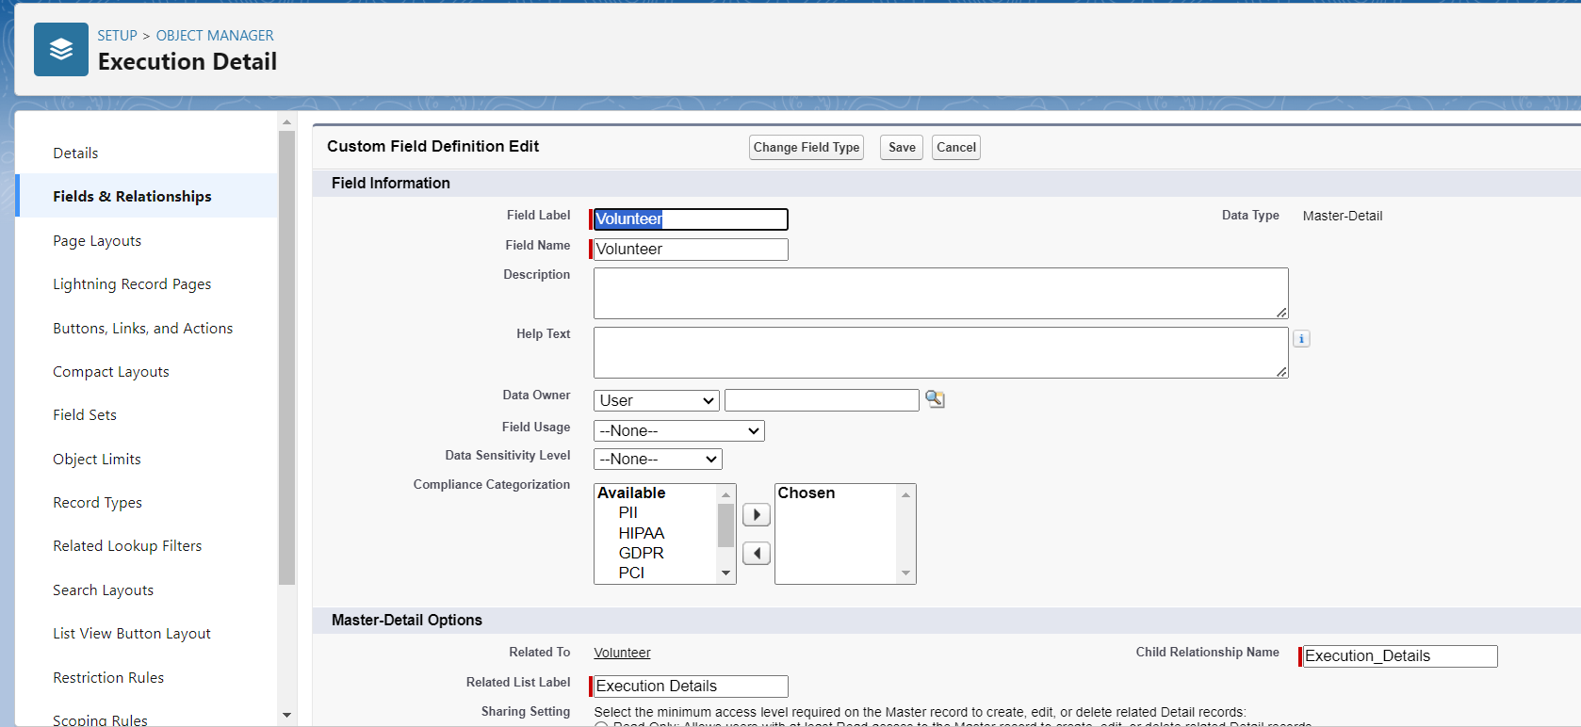

**5.1.3 Creation of Master Detail Relationship Field on Execution Details Object:**

1. Go to setup >> click on Object Manager >> type object name (Execution Details) in the search bar >> click on the object.
2. Now click on “Fields & Relationships” >> New
3. Select Master Detail relationship
4. Select the related object “Task” and click next.
5. Field Name: Task
6. Field label: Auto generated
7. Next >> Next >> Save.

Created the field as per the above instructions and you can observe all the details in the below image:

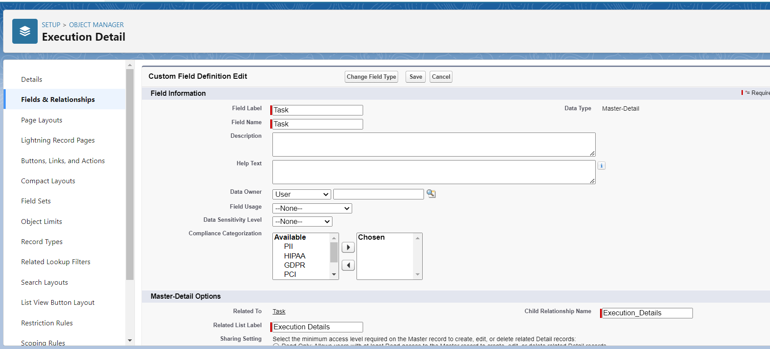

**5.1.4 Creation of Lookup Relationship Field on Drop-Off Point Object:**

1. Go to setup >> click on Object Manager >> type object name (Task) in the search bar >> click on the object.
2. Now click on “Fields & Relationships” >> New
3. Select Lookup relationship
4. Select the related object “Drop-Off Point” and click next.
5. Field Name : Venue
6. Field label: Venue__c
7. Next >> Next >> Save.

Created the field as per the above instructions and you can observe all the details in the below image:

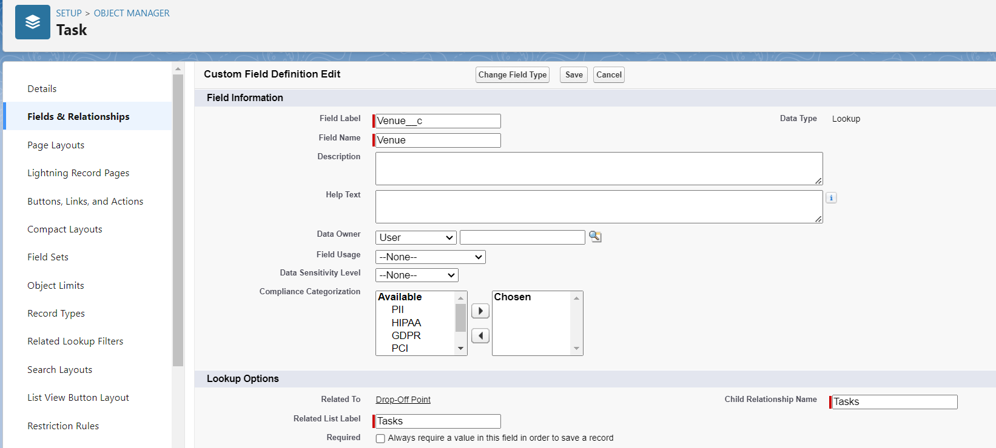

**5.1.5 Creation of Lookup Relationship Field on Task Object :**

1. Go to setup>> click on Object Manager >> type object name (Task) in the search bar >> click on the object.
2. Now click on “Fields & Relationships” >> New
3. Select Lookup relationship
4. Select the related object “Venue” and click next.
5. Field Name: Sponsored By
6. Field label: Auto generated
7. Next >> Next >> Save.

Created the field as per the above instructions and you can observe all the details in the below image:

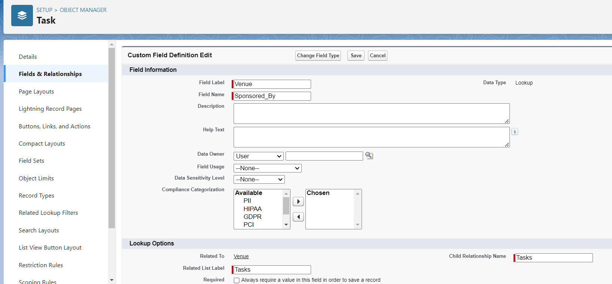

**5.1.6 Creation of Lookup Relationship Field on Task Object:**

1. Go to setup>> click on Object Manager >> type object name (Task) in the search bar >> click on the object.
2. Now click on “Fields & Relationships” >> New
3. Select Lookup relationship
4. Select the related object “Drop-Off point” and click next.
5. Field Name: Drop-Off point
6. Field label: Auto generated
7. Next >> Next >> Save.

Created the field as per the above instructions and you can observe all the details in the below image:

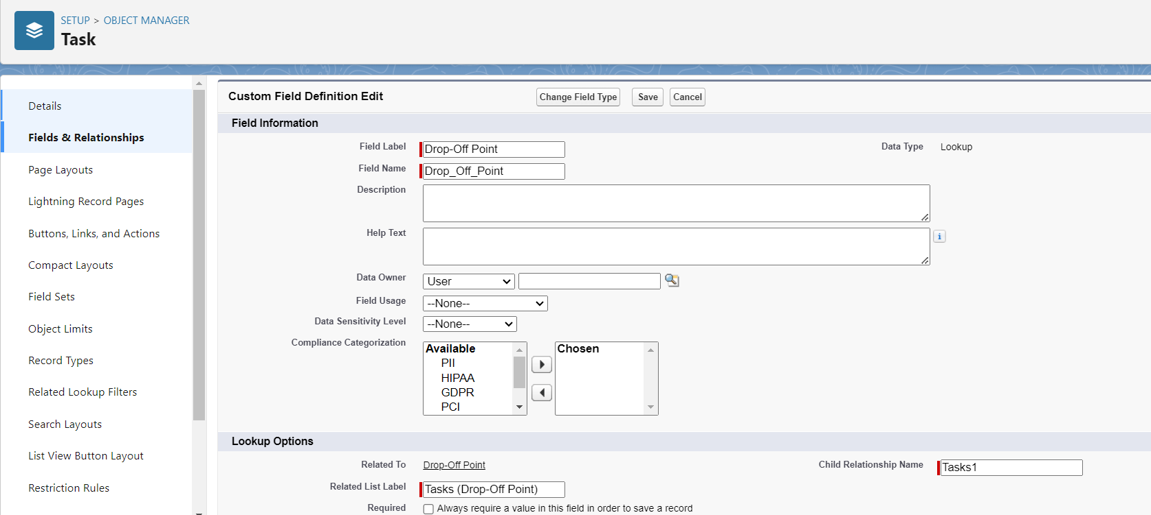

**5.1.7 Creation of Lookup Relationship Field on Drop-Off Point Object:**

1. Go to setup>> click on Object Manager >> type object name (Drop-Off point) in the search bar >> click on the object.
2. Now click on “Fields & Relationships” >> New
3. Select Lookup relationship
4. Select the related object “Venue” and click next.
5. Field Name: Drop-Off point
6. Field label: Auto generated
7. Next >> Next >> Save.

Created the field as per the above instructions and you can observe all the details in the below image:

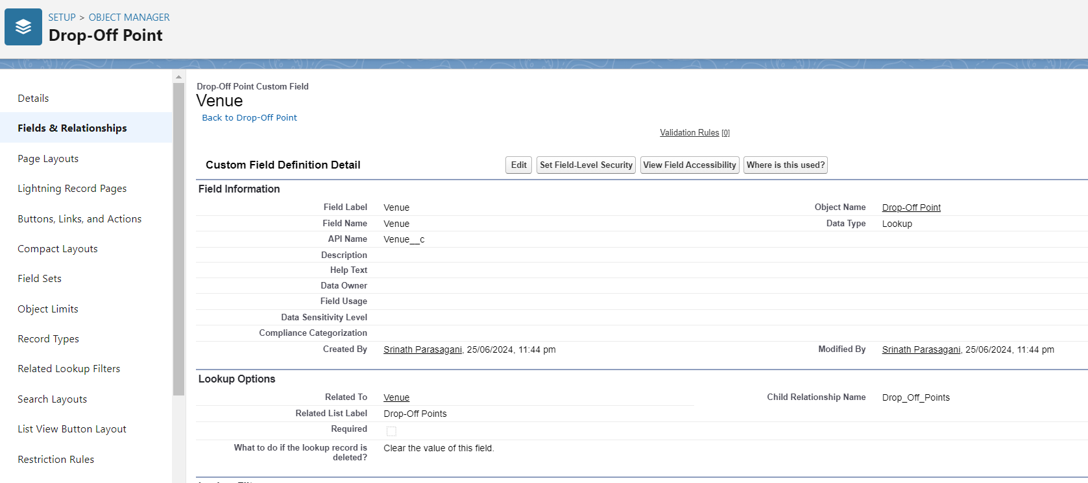

**5.2 Creation of Fields for The Venue Object**

1. Go to setup>> click on Object Manager >> type object name (Venue) in search bar >> click on the object.
2. Now click on “Fields & Relationships” >> New
3. Select Data type as a “Email” and Click on Next
4. Fill the Above as following:

* Field Label: Contact Email
* Field Name: Contact Email
* Click on required check box
* Click on Next >> Next >> Save and new.

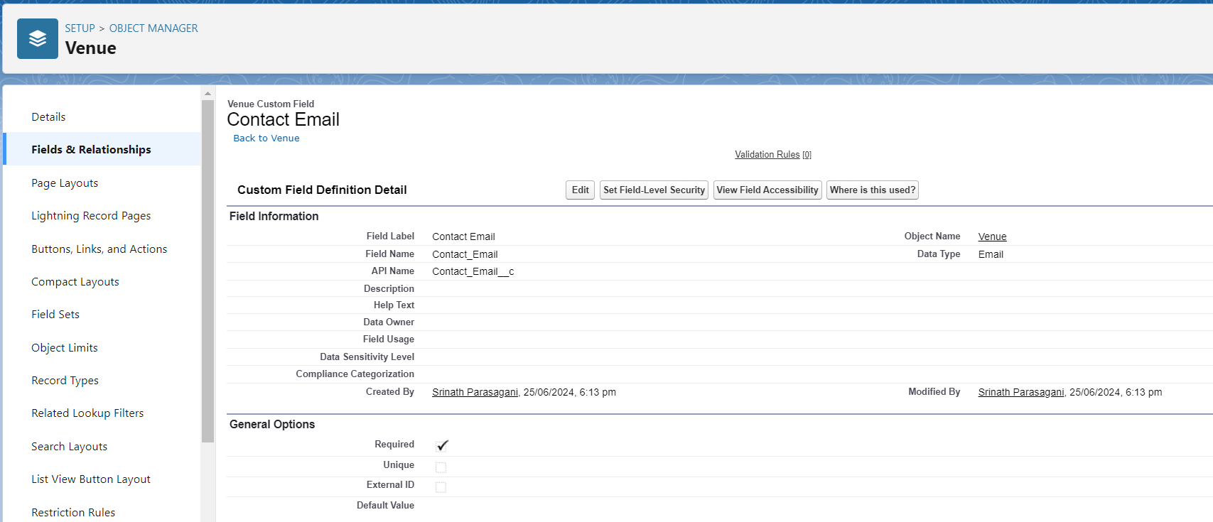

**To create another fields in an object:**

1. Go to setup >> click on Object Manager >> type object name (Venue) in search bar >> click on the object.
2. Now click on “Fields & Relationships” >> New
3. Select Data type as a “Phone” and Click on Next
4. Fill the Above as following:

* Field Label: Contact Phone
* Field Name: Contact Phone
* Click on required check box
* 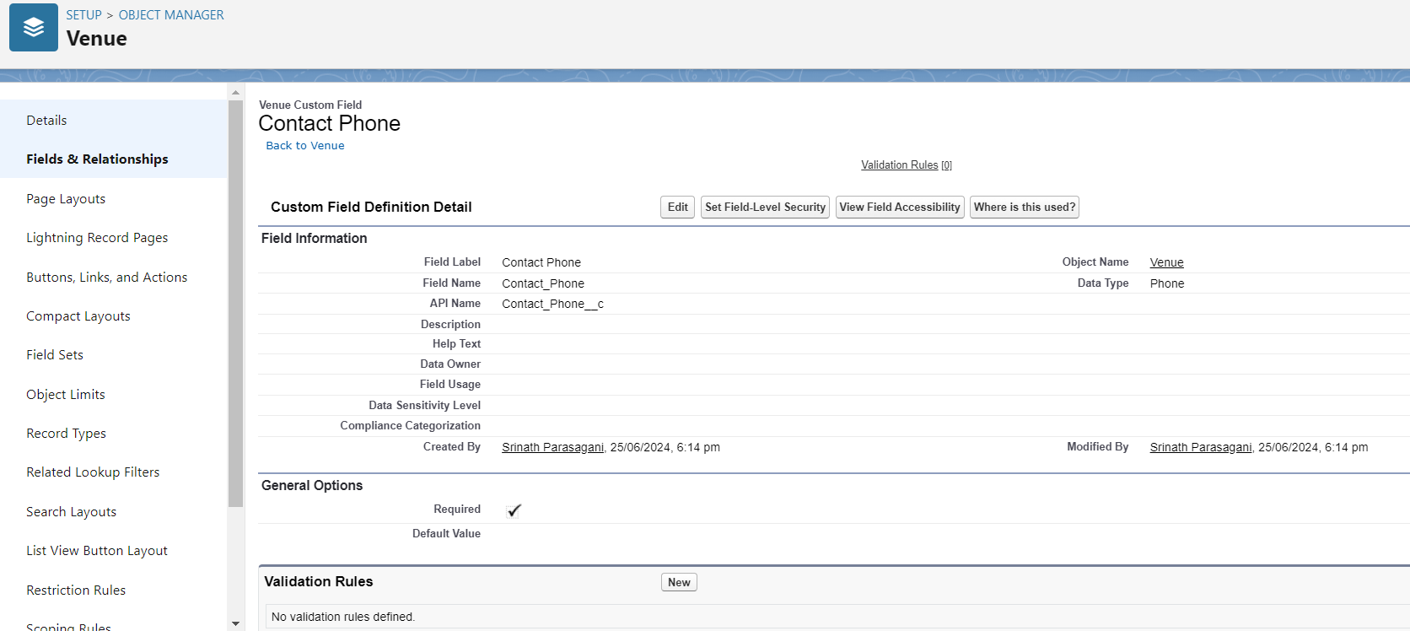Click on Next >> Next >> Save and new.

**To create another fields in an object:**

1. Go to setup >> click on Object Manager >> type object name (Venue) in search bar >>click on the object.
2. Now click on “Fields & Relationships” >> New
3. Select Data type as a “Geolocation” and Click on Next
4. Fill the Above as following:

* Field Label : Location
* Decimal Places : 4
* Field Name : Location
* Description : Enter the Geolocation of your Venue
* Click on Next >> Next >> Save and new.

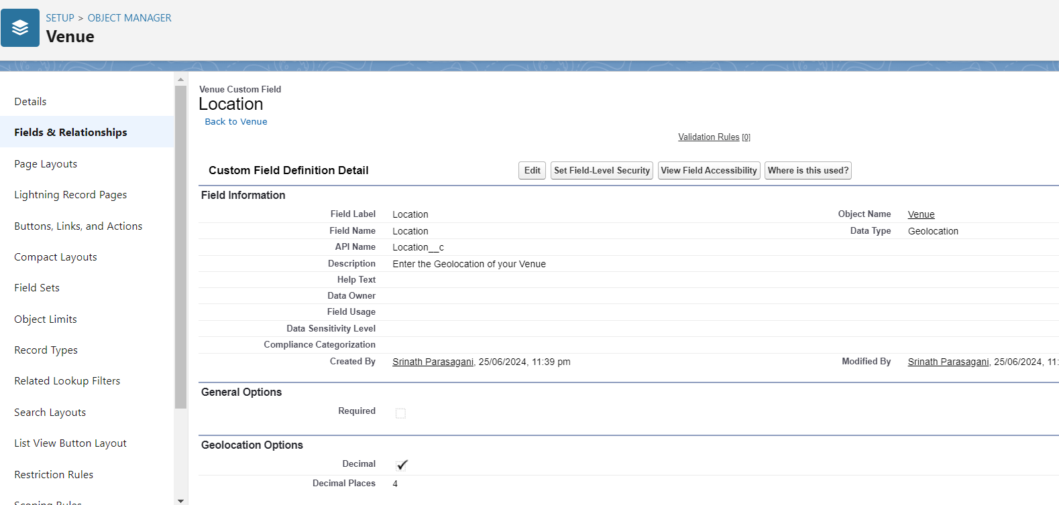

**To create another fields in an object:**

1. Go to setup >> click on Object Manager >> type object name (Venue) in search bar >> click on the object.
2. Now click on “Fields & Relationships” >> New
3. Select Data type as a “Long Text Area” and Click on Next
4. Fill the Above as following:

* Field Label: Venue Location
* Field Name: Venue_Location and Click on Next >> Next >> Save and new

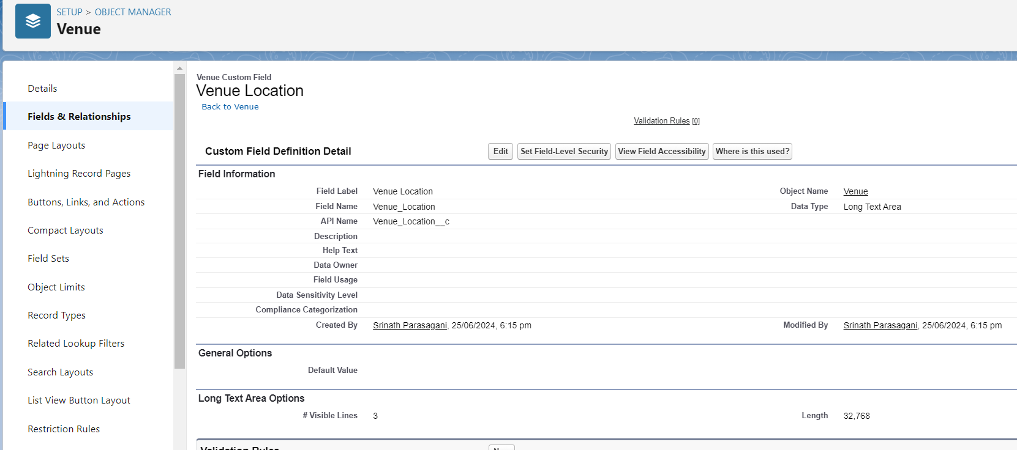

**5.3 Creation of Fields for The Drop-Off Point Object**

Go to setup >> click on Object Manager >> type object name(Drop-Off point) in search bar >> click on the object.

2. Now click on “Fields & Relationships” >> New

3. Select Data type as a “Geolocation” and Click on Next

4. Fill the Above as following:

* Field Label : Location 2
* Field Name : gets auto generated
* Description : Enter the Geolocation of the Drop off Point
* Geolocation Options : select Decimal
* Decimal Places : 4
* Click on Next >> Next >> Save and new.

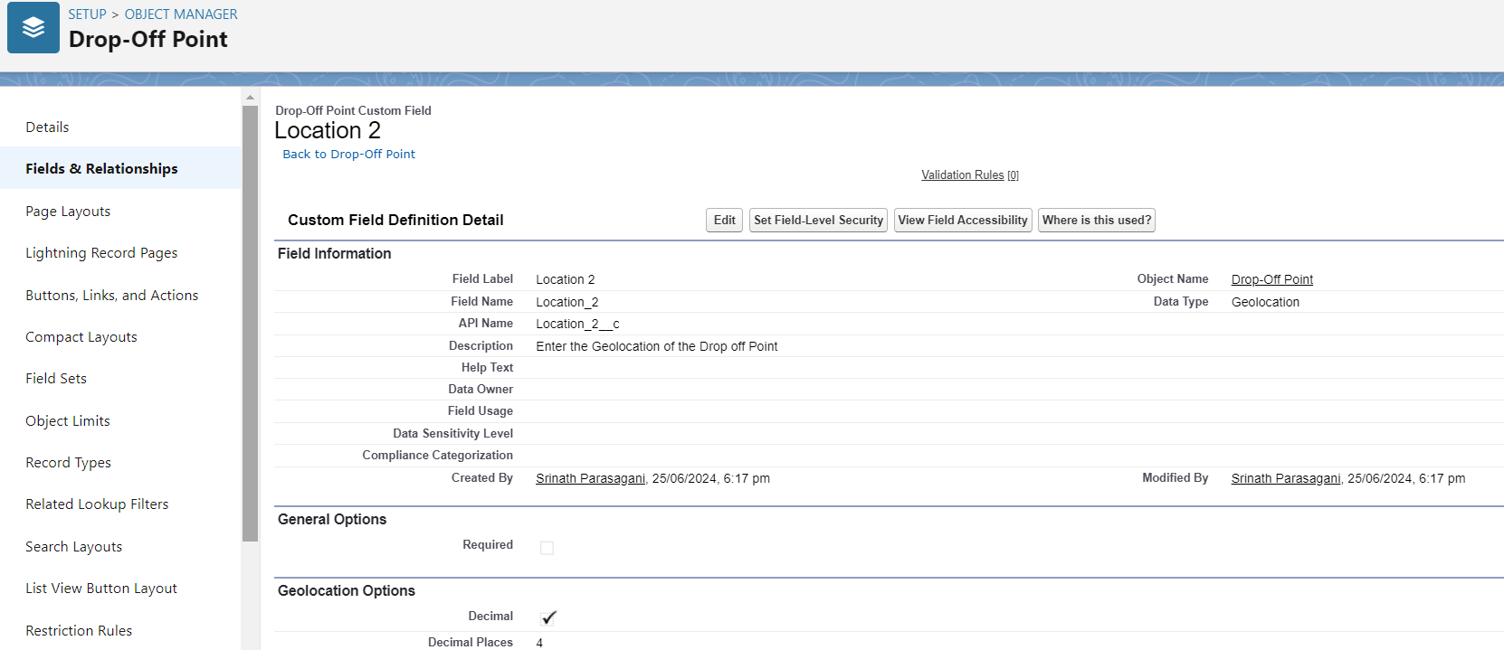

**To create another fields in an object:**

1. Go to setup >> click on Object Manager >> type object name(Drop-Off point) in search bar >> click on the object.
2. Now click on “Fields & Relationships” >> New
3. Select Data type as a “Formula” and Click on Next
4. Fill the Above as following:

* Field Label : distance calculation
* Field Name :distance_calculation
* Formula Return Type : Number
* Formula Options : DISTANCE( Location_2__c ,  Venue__r.Location__c , 'km')
* Click on Next >> Next >> Save and new.

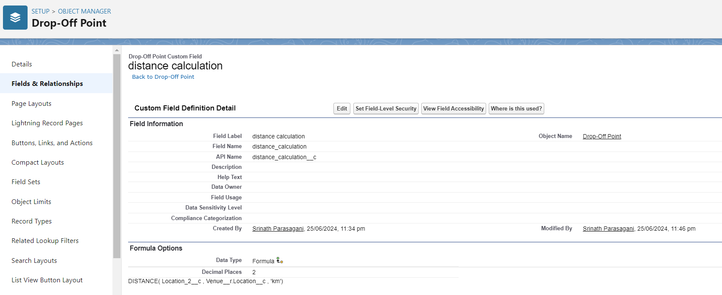

**To create another fields in an object:**

1. Go to setup >> click on Object Manager >> type object name(Drop-Off point) in search bar >> click on the object.
2. Now click on “Fields & Relationships” >> New
3. Select Data type as a “Picklist” and Click on Next
4. Fill the Above as following:

* Field Label : State
* Field Name : State
* Enter values, with each value separated by a new line :

Andhra Pradesh

Arunachal Pradesh

Assam

Bihar

Chhattisgarh

Goa

Gujarat

Haryana

Himachal Pradesh

Jharkhand

Karnataka

Kerala

Maharashtra

Madhya Pradesh

Manipur

Meghalaya

Mizoram

Nagaland

Odisha

Punjab

Rajasthan

Sikkim

Tamil Nadu

Tripura

Telangana

Uttar Pradesh

Uttarakhand

West Bengal

Andaman & Nicobar (UT)

Chandigarh (UT)

Dadra & Nagar Haveli and Daman & Diu (UT)

Delhi [National Capital Territory (NCT)]

Jammu & Kashmir (UT)

Ladakh (UT)

Lakshadweep (UT)

Puducherry (UT)

* Click on required check box
* Click on Next >> Next >> Save and new.

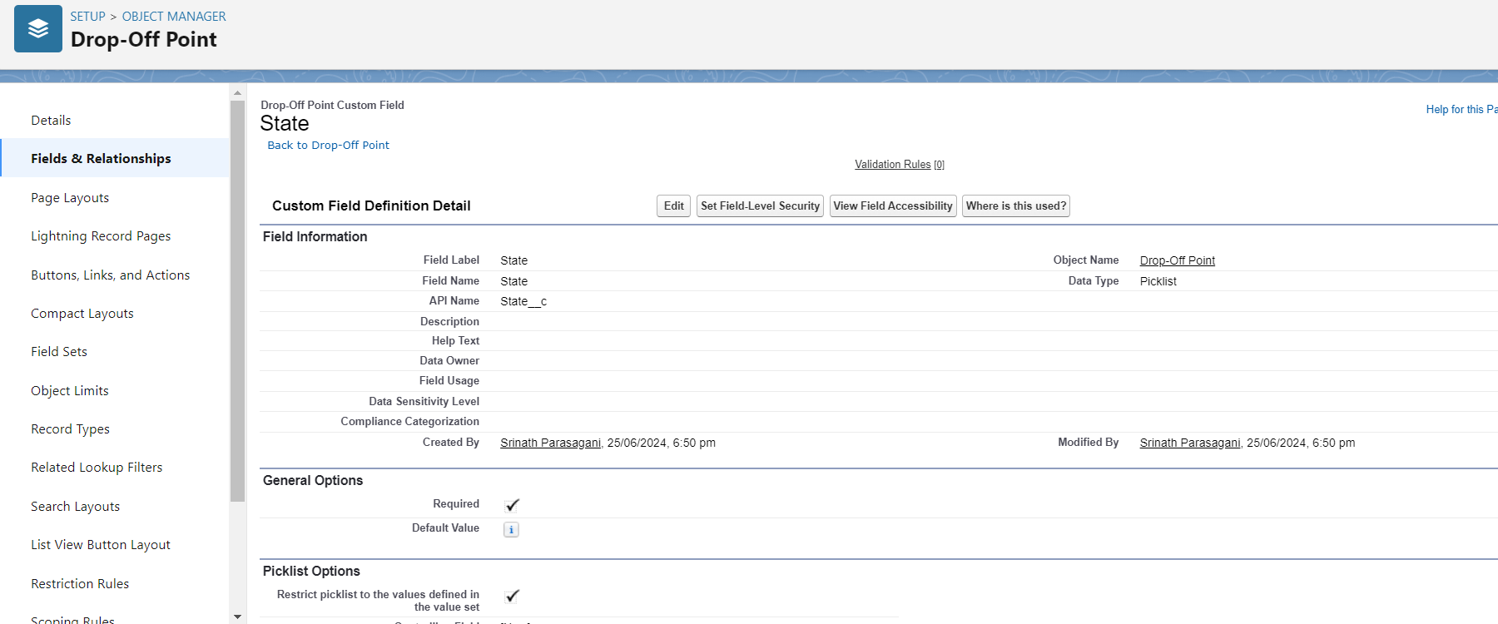

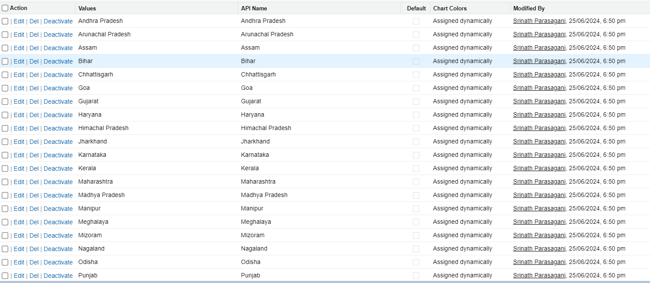

**To create another fields in an object:**

1. Go to setup >> click on Object Manager >> type object name(Drop-Off point) in search bar >> click on the object.
2. Now click on “Fields & Relationships” >> New
3. Select Data type as a “Number” and Click on Next
4. Fill the Above as following:

* Field Label : Distance
* Field Name : Distance
* Length : 14
* Decimal Places : 4
* Click on required check box
* Click on Next >> Next >> Save and new

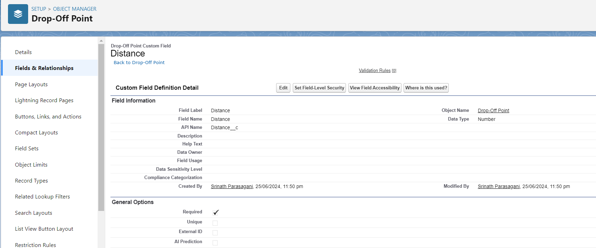

### 5.4 Creation of Fields for The Task Object

Go to setup>> click on Object Manager >> type object name (Task) in search bar >> click on the object.

2. Now click on “Fields & Relationships” >> New

3. Select Data type as a “Auto Number” and Click on Next

4. Fill the Above as following:

* Field Label: Task ID
* Display Format: TASK-{0}
* Starting Number: 1
* Field Name: gets auto generated
* Click on required check box
* Click on Next >> Next >> Save and new.

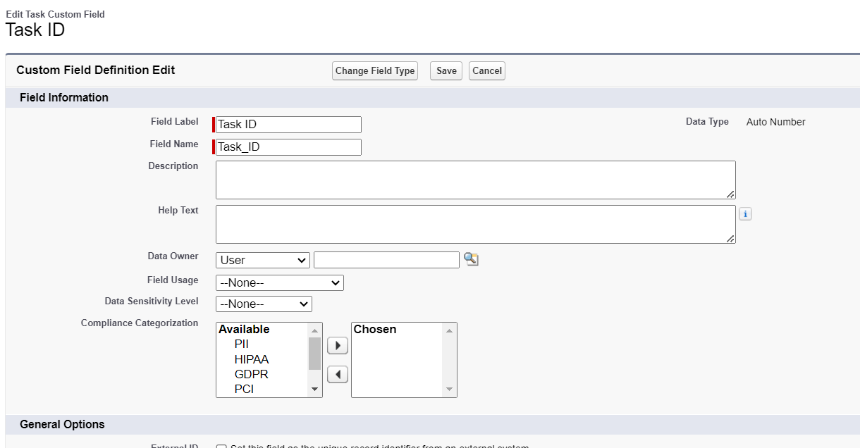

**To create another fields in an object:**

1. Go to setup >> click on Object Manager >> type object name(Task) in search bar >> click on the object.
2. Now click on “Fields & Relationships” >> New
3. Select Data type as a “Date” and Click on Next
4. Fill the Above as following:

* Field Label : Date
* Field Name : Date
* Click on required check box
* Click on Next >> Next >> Save and new.

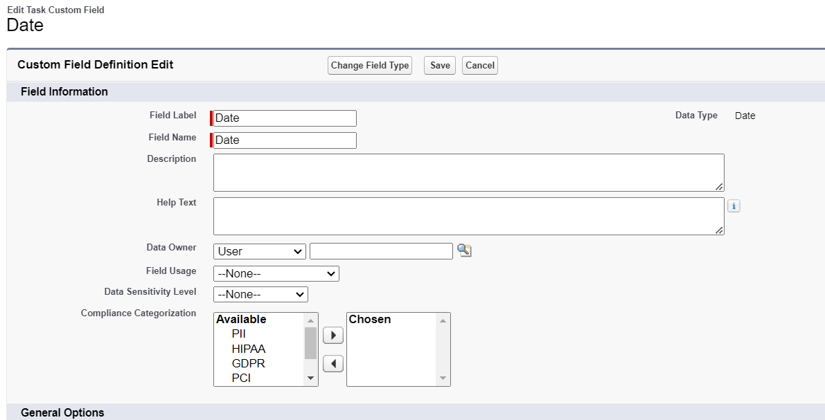

**To create another fields in an object:**

1. Go to setup >> click on Object Manager >> type object name(Task) in search bar >> click on the object.
2. Now click on “Fields & Relationships” >> New
3. Select Data type as a “Picklist (Multi-Select)” and Click on Next
4. Fill the Above as following:

* Field Label : Food Category
* Field Name : Food Category
* Enter values, with each value separated by a new line :

Veg

Non-Veg

Salad

Snack

* Click on required check box
* Click on Next >> Next >> Save and new.

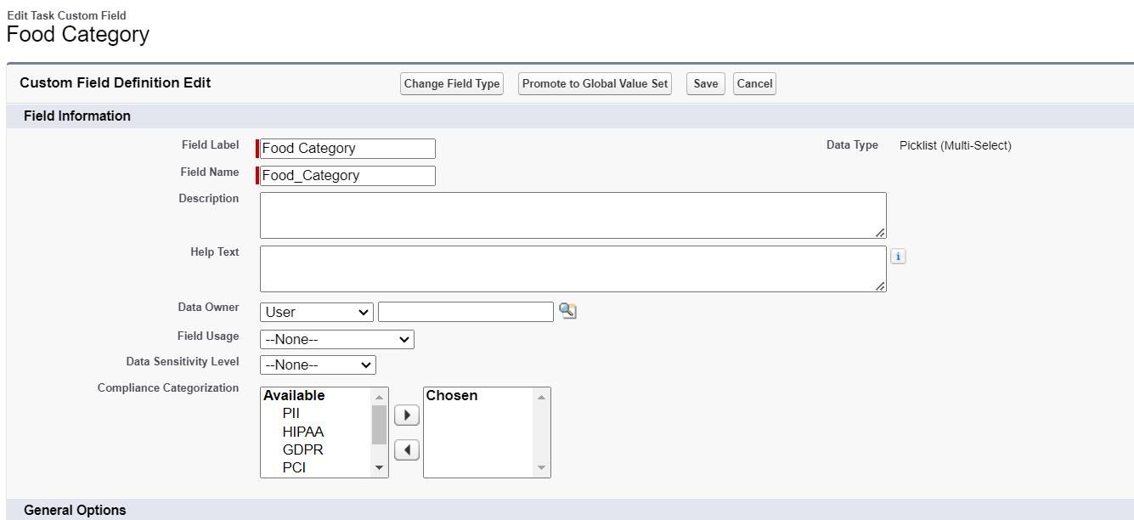

**To create another fields in an object:**

1. Go to setup >> click on Object Manager >> type object name(Task) in search bar >> click on the object.
2. Now click on “Fields & Relationships” >> New
3. Select Data type as a “Number” and Click on Next
4. Fill the Above as following:

* Field Label : Number of People Served
* Field Name :Number_of_People_Served
* Click on required check box
* Click on Next >> Next >> Save and new.

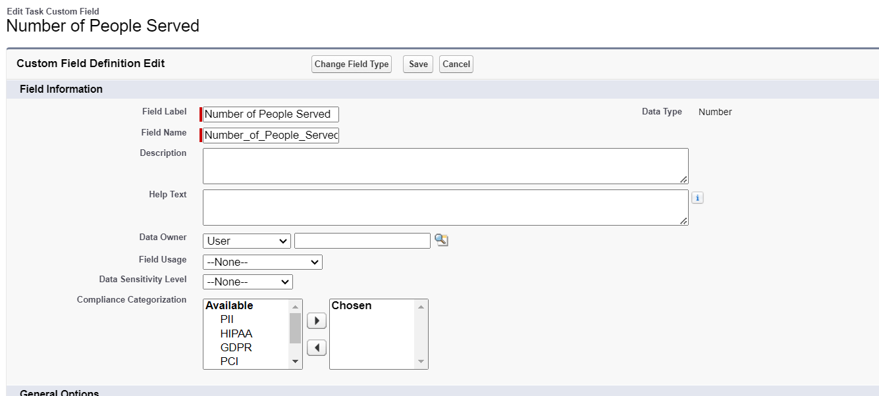

**To create another fields in an object:**

1. Go to setup >> click on Object Manager >> type object name(Task) in search bar >> click on the object.
2. Now click on “Fields & Relationships” >> New
3. Select Data type as a “Text” and Click on Next
4. Fill the Above as following:

* Field Label : Name of the Person
* Field Name :Name_of_the_Person
* Click on Next >> Next >> Save and new.

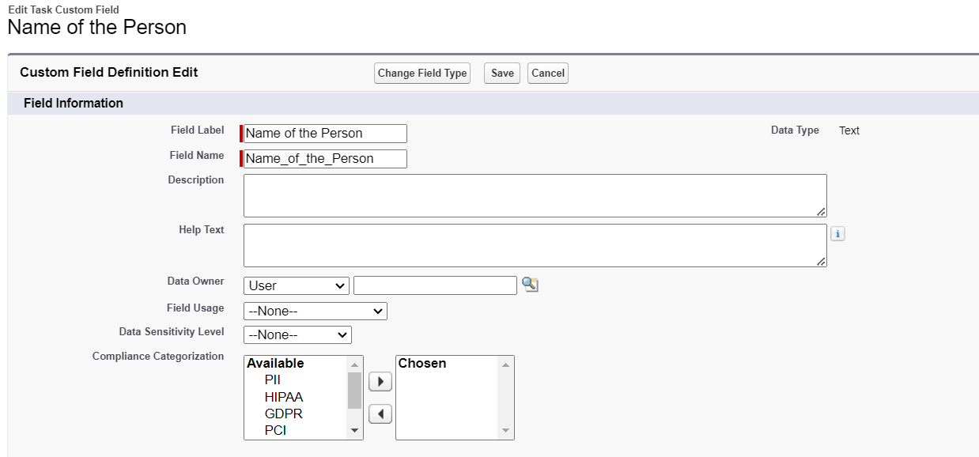

**To create another fields in an object:**

1. Go to setup>> click on Object Manager >> type object name(Task) in search bar >> click on the object.
2. Now click on “Fields & Relationships” >> New
3. Select Data type as a “Phone” and Click on Next
4. Fill the Above as following:

* Field Label : Phone
* Field Name : Phone
* Click on Next >> Next>> Save and new.

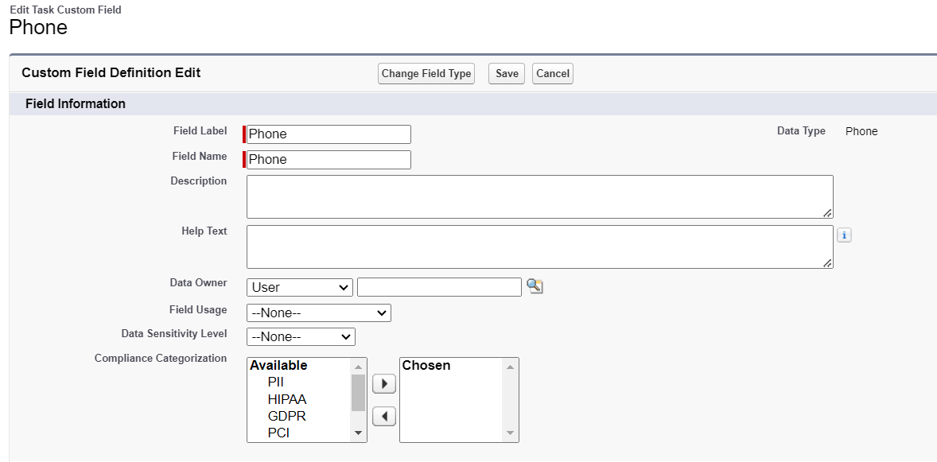

**To create another fields in an object:**

1. Go to setup >> click on Object Manager >> type object name(Task) in search bar >> click on the object.
2. Now click on “Fields & Relationships” >> New
3. Select Data type as a “Pick List” and Click on Next
4. Fill the Above as following:

* Field Label : Rating
* Field Name : Rating
* Enter values, with each value separated by a new line :

1

2

3

4

5

* Click on Next >> Next >> Save and new.

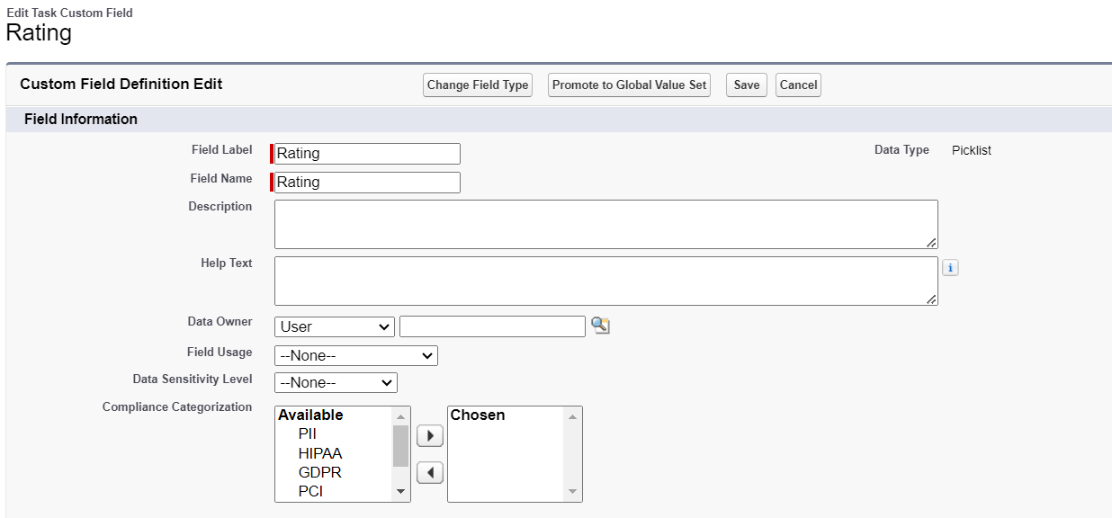

**To create another fields in an object:**

1. Go to setup >> click on Object Manager >> type object name(Task) in search bar >> click on the object.
2. Now click on “Fields & Relationships” >> New
3. Select Data type as a “Long Text Area” and Click on Next
4. Fill the Above as following:

* Field Label : Feedback
* Field Name : Feedback
* Click on Next >> Next >> Save and new.

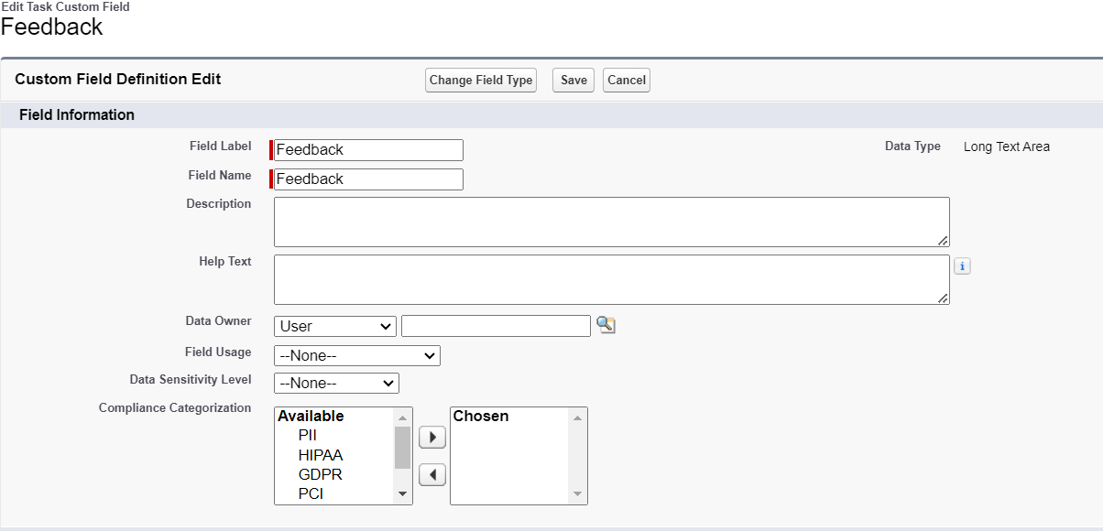

### 5.5 Creation of Fields for The Volunteer Object

1. Go to setup >> click on Object Manager >> type object name(Volunteer) in search bar >> click on the object.

2. Now click on “Fields & Relationships” >> New

3. Select Data type as a “Auto Number” and Click on Next

4. Fill the Above as following:

* Field Label : Volunteer ID
* Field Name : gets auto generated
* Click on required check box
* Click on Next >> Next >> Save and new.
* Click on Next >> Next >> Save and new.

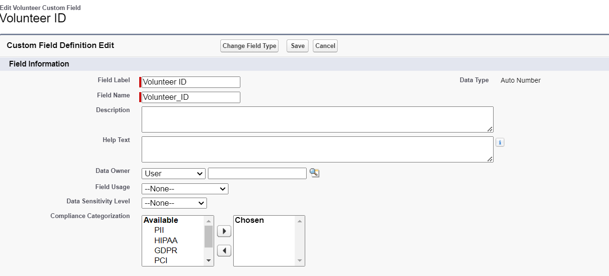

**To create another fields in an object:**

1. Go to setup >> click on Object Manager >> type object name(Volunteer) in search bar >> click on the object.
2. Now click on “Fields & Relationships” >> New
3. Select Data type as a “Picklist” and Click on Next
4. Fill the Above as following:

* Field Label : Gender
* Field Name : Gender
* Enter values, with each value separated by a new line :

Female

Male

* Click on Next >> Next >> Save and new.

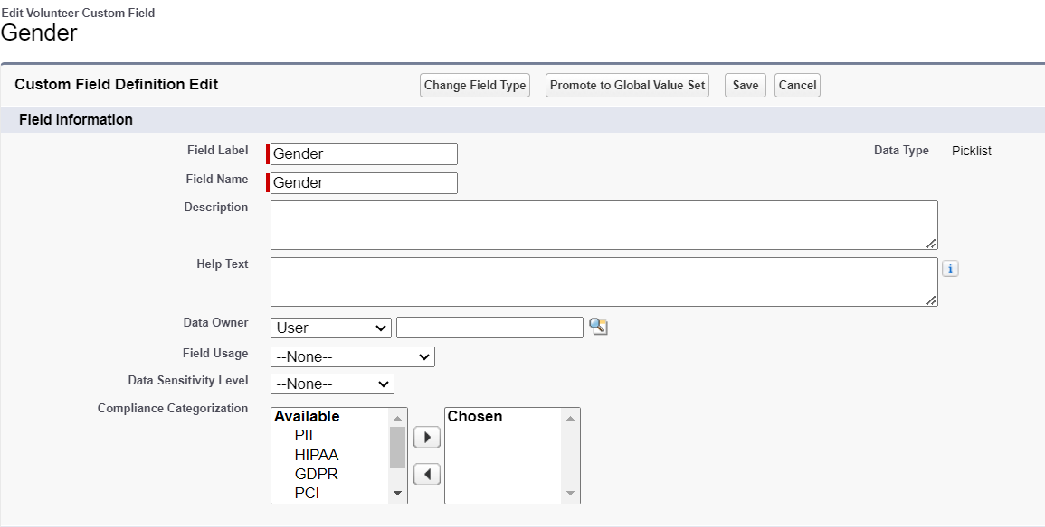

**To create another fields in an object:**

1. Go to setup >> click on Object Manager >> type object name(Volunteer) in search bar >> click on the object.
2. Now click on “Fields & Relationships” >> New
3. Select Data type as a “Date” and Click on Next
4. Fill the Above as following:

* Field Label : Available On
* Field Name : Available On
* Click on required check box
* Click on Next >> Next >> Save and new.

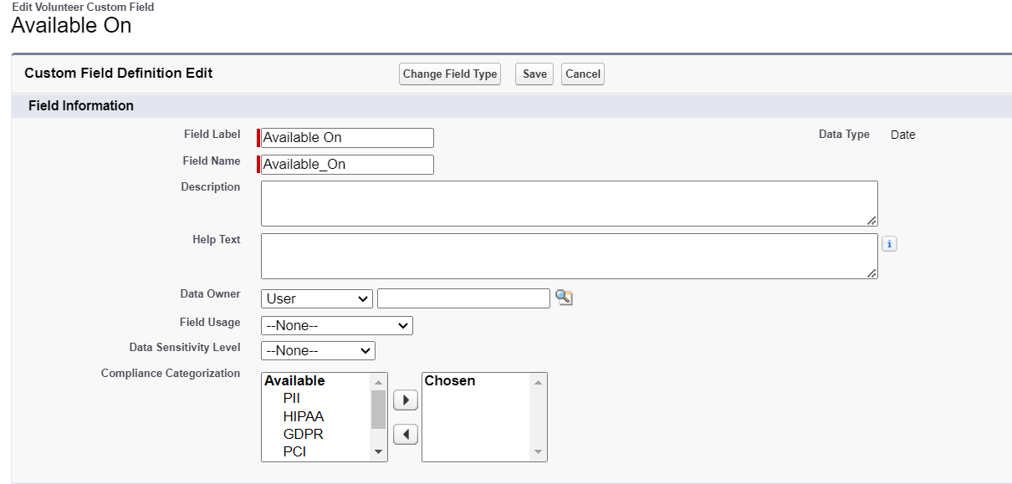

**To create another fields in an object:**

1. Go to setup >> click on Object Manager >> type object name(Volunteer) in search bar >> click on the object.
2. Now click on “Fields & Relationships” >> New
3. Select Data type as a “Number” and Click on Next
4. Fill the Above as following:

* Field Label : Age
* Field Name : Age
* Click on required check box
* Click on Next >> Next>> Save and new.

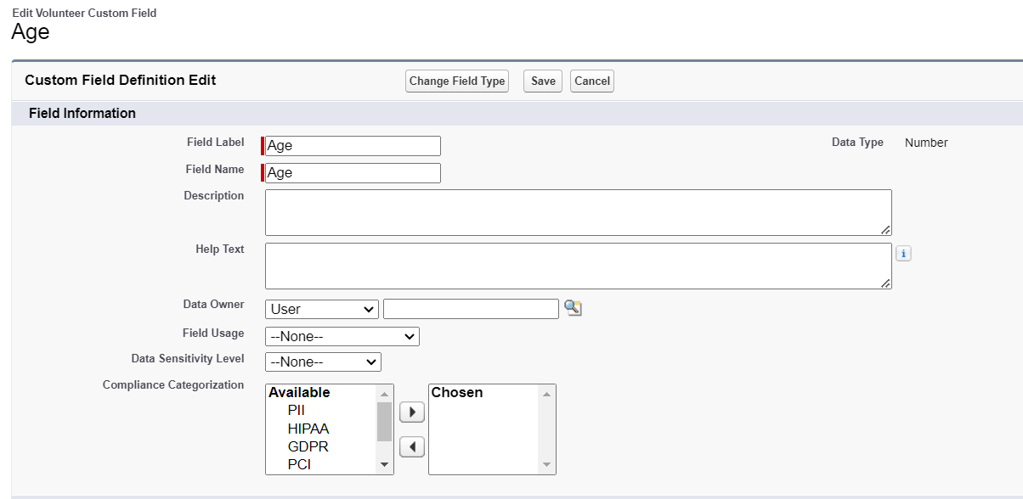

**To create another fields in an object:**

1. Go to setup >> click on Object Manager >> type object name(Volunteer) in search bar >> click on the object.
2. Now click on “Fields & Relationships” >> New
3. Select Data type as a “Email” and Click on Next
4. Fill the Above as following:

* Field Label : Email
* Field Name : Email
* Click on required check box
* Click on Next>> Next >> Save and new.

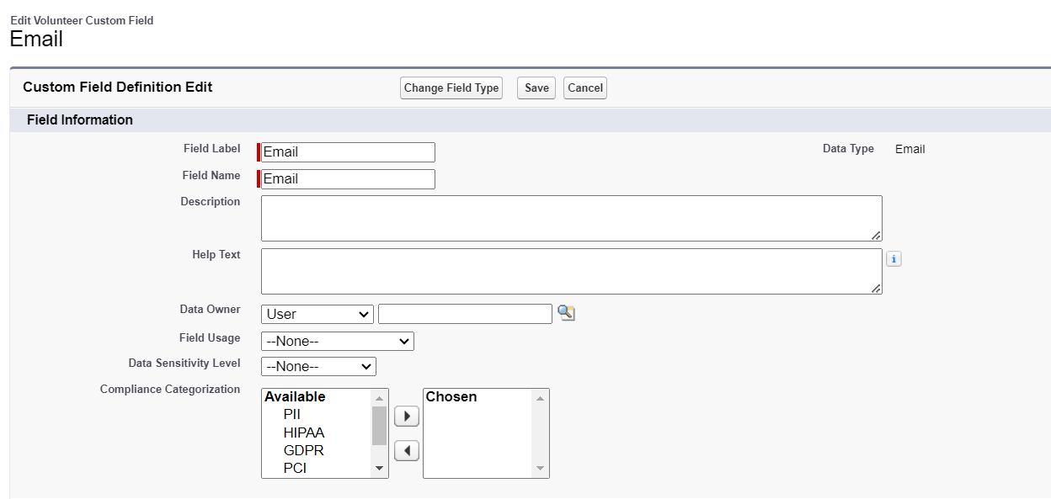

**To create another fields in an object:**

1. Go to setup >> click on Object Manager >> type object name(Volunteer) in search bar >> click on the object.
2. Now click on “Fields & Relationships” >> New
3. Select Data type as a “Number” and Click on Next
4. Fill the Above as following:

* Field Label : Contact Number
* Field Name :Contact_Number
* Click on required check box
* Click on Next >> Next >> Save and new.

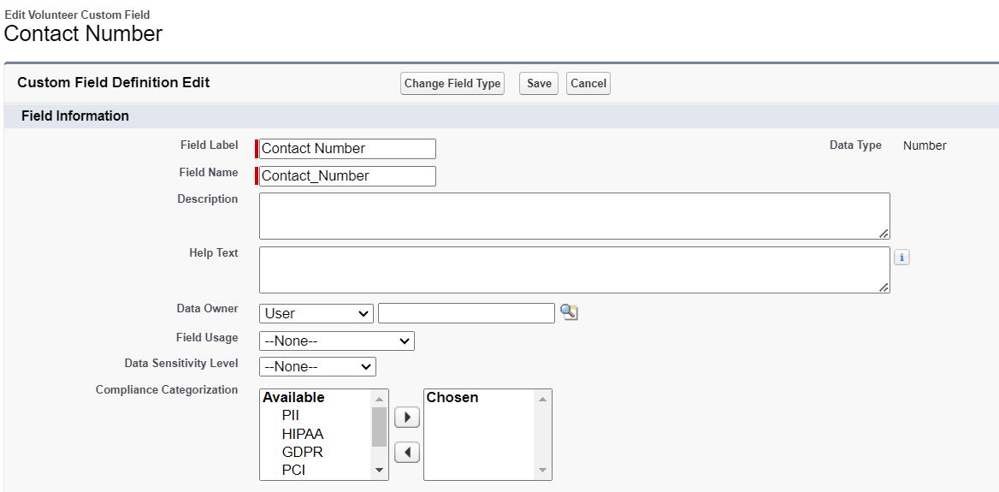

**To create another fields in an object:**

1. Go to setup >> click on Object Manager >> type object name(Volunteer) in search bar >> click on the object.
2. Now click on “Fields & Relationships” >> New
3. Select Data type as a “Text Area (Long)” and Click on Next
4. Fill the Above as following:

* Field Label : Address
* Field Name : Address
* Click on Next >> Next >> Save and new.

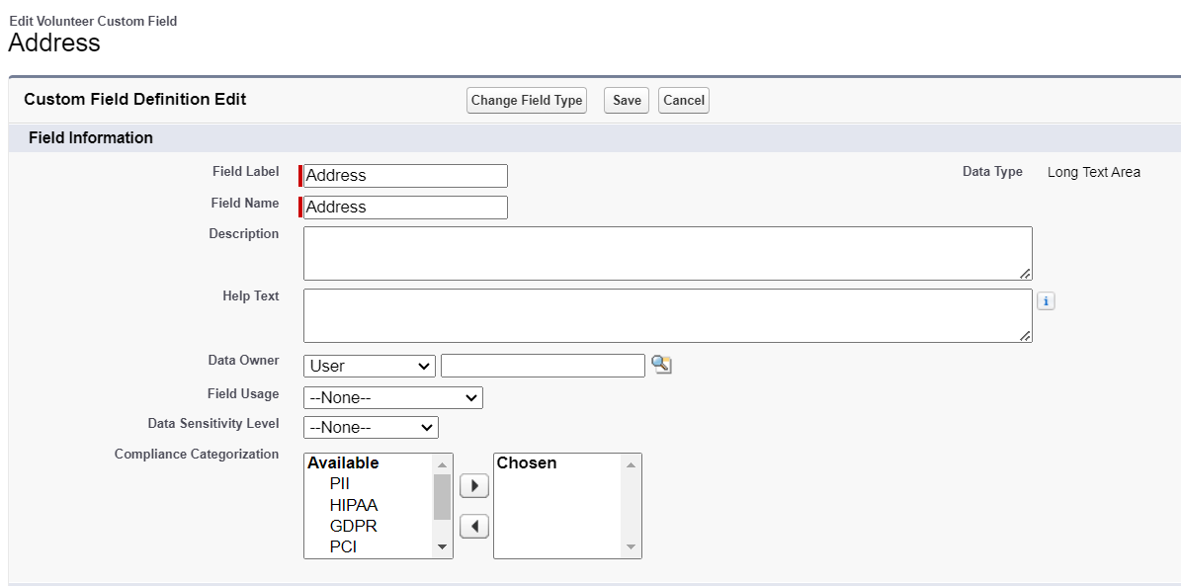

**To create another fields in an object:**

1. Go to setup >> click on Object Manager >> type object name(Volunteer) in search bar >> click on the object.
2. Now click on “Fields & Relationships” >> New
3. Select Data type as a “Date” and Click on Next
4. Fill the Above as following:

* Field Label : Date of Birth
* Field Name :Date_of_Birth
* Click on Next >> Next >> Save and new.

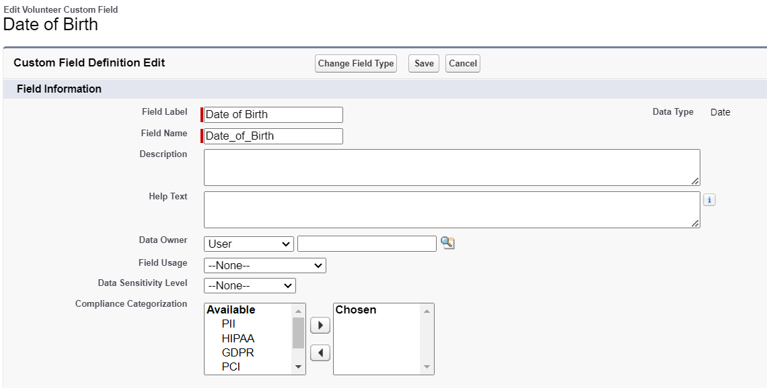

**To create another fields in an object:**

1. Go to setup >> click on Object Manager >> type object name(Volunteer) in search bar >> click on the object.
2. Now click on “Fields & Relationships” >> New
3. Select Data type as a “text” and Click on Next
4. Fill the Above as following:

* Field Label : Owner Name
* Field Name : Owner Name
* Click on Next >> Next >> Save and new.

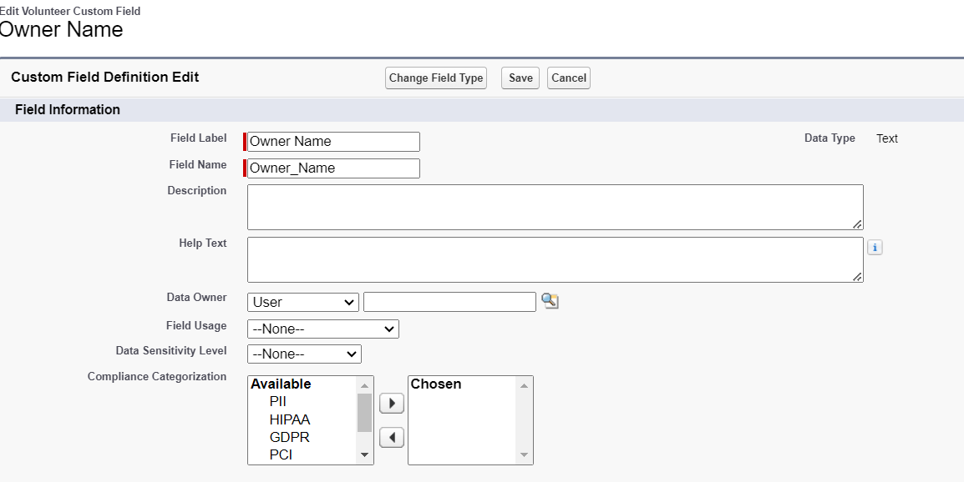

### 5.6 Creation of Fields for The Execution Details Object

1.Go to setup >> click on Object Manager >> type object name(Volunteer) in search bar >> click on the object.

2. Now click on “Fields & Relationships” >> New

3. Select Data type as a “Auto Number” and Click on Next

4. Fill the Above as following:

* Field Label : Execution ID
* Field Name : gets auto generated
* Click on required check box
* Click on Next >> Next >> Save and new.

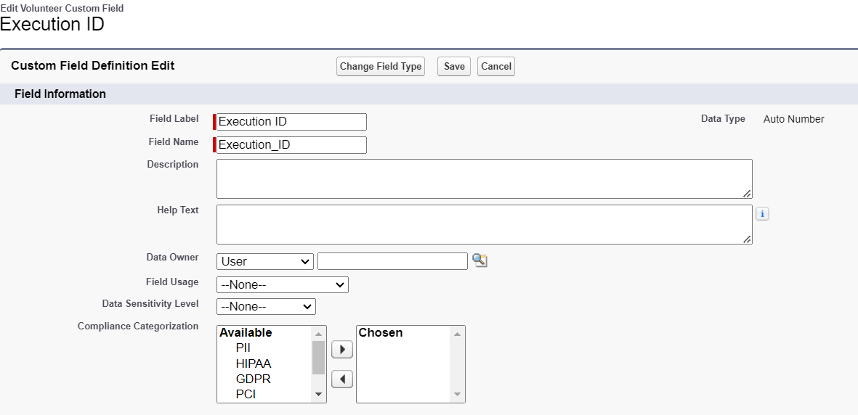

## 6.Flows

### 6.1 Created Flow to Create a Record in Venue Object

1. Go to setup >> type Flow in quick find box >> Click on the Flow and Select the New Flow.
2. Select the Screen flow. Click on create.

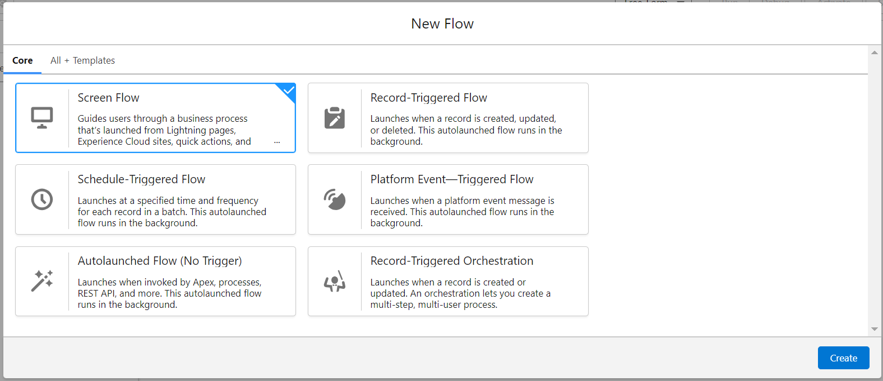

1. Click on the ‘+’ icon in between start and end, and click on screen element.
2. Under the Screen Properties:

Label : Venue Details

API Name :Venue_Details

1. Now lets add components in this flow. Click on Text Component and name it as:

Label : Venue Name

API Name :Venue_Name

1. Click on Email Component and name it as:

Label : Email

API Name :Contact_Email

1. Click on Phone Component and name it as:

Label : Phone

API Name :Contact_Phone

1. Click on Text Component and name it as:

Label : Venue Location

API Name :Venue_Location

1. Click on Number Component and name it as:

Label : Latitude

API Name : Latitude

1. Click on Number Component and name it as:

Label : longitude

API Name : longitude

1. Next click on Done. This would like below

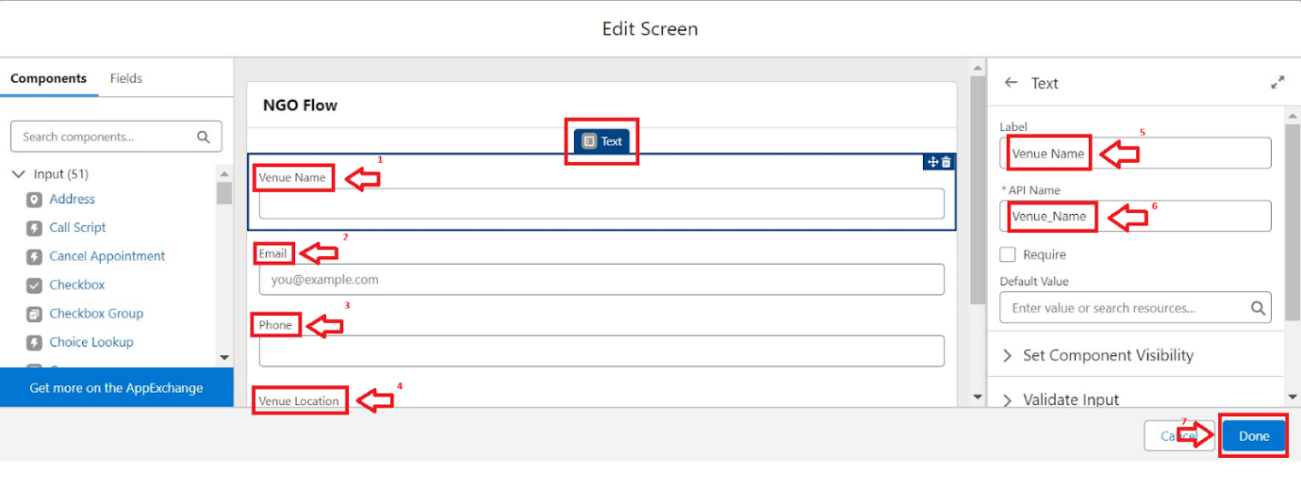

1. Click on the ‘+’ icon in between Venue details and end, and click on create record element.
2. Now label it as

Label : Create Venue Record

API Name :Create_Venue_Record

How Many Records to Create : One

How to Set the Record Fields : Use separate resources, and literal values

Object : Venue

Set Field Values for the Venue : Click on ‘Add Field’ 5 times

Field : Value = Contact_Email__c : {!Contact_Email.value}

Field : Value = Contact_Phone__c : {!Contact_Phone.value}

Field : Value = Name : {!Venue_Name}

Field : Value = Venue_Location__c : {!location}

Field : Value = Location__Latitude__s : {!latitude}

Field : Value = Location__Longitude__s : {!longitude}

1. This would look like:

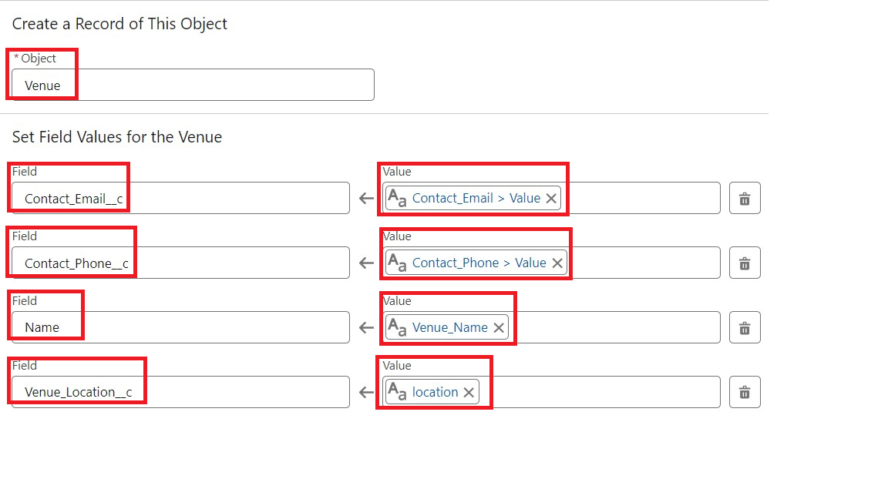

1. Click on Save as:

Flow Label : Venue Form

Flow API Name :Venue_Form

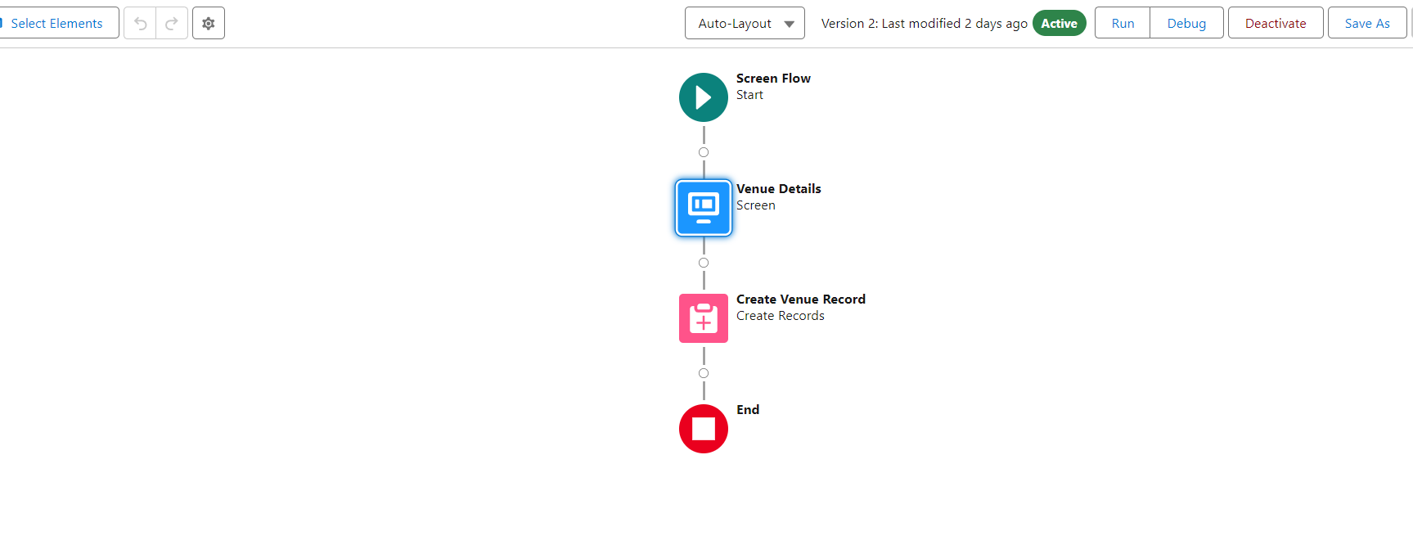

In the above picture, you can see a screen named **Venue Details** and Created records named **Create Venue Record.**

## 7.Trigger

### 7.1 Created A Trigger

1. Log into the trailhead account, navigate to the gear icon in the top right corner.
2. Click on developer console and you will be navigated to a new console window.
3. Click on the File menu in the toolbar, and click on new >> Trigger.
4. Enter the trigger name and the object to be triggered.

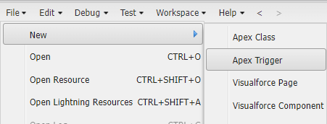

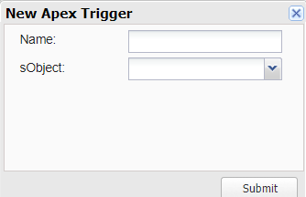

1. Enter Name :DropOffTrigger

sObject: Drop-Off Point

1. Click on Submit.

### 7.2 Trigger Code

(This Trigger is to assign Distance field to the Distance Calculation field. So that we can assign the distance in the sharing rules.)

**Code:**

trigger DropOffTrigger on Drop_Off_point__c (before insert) {

    for(Drop_Off_point__c Drop : Trigger.new){

        Drop.Distance__c = Drop.distance_calculation__c;

    }

}

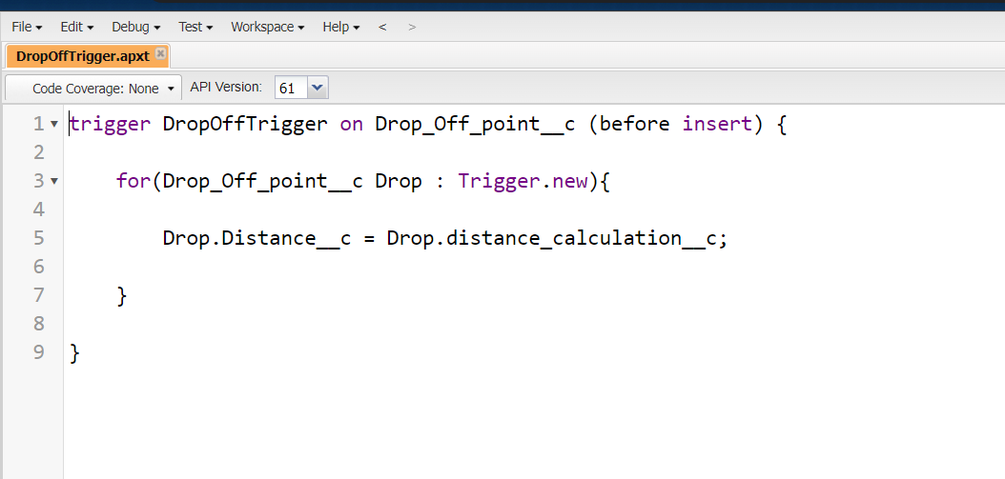

## 8.Profiles

1. Go to setup page >> type Profiles in Quick Find bar >> click on Profiles >> click on ‘S’
2. Click on Clone beside Standard Platform User.
3. Under Clone Profile:

Profile Name: NGOs Profile

1. Then click on Save

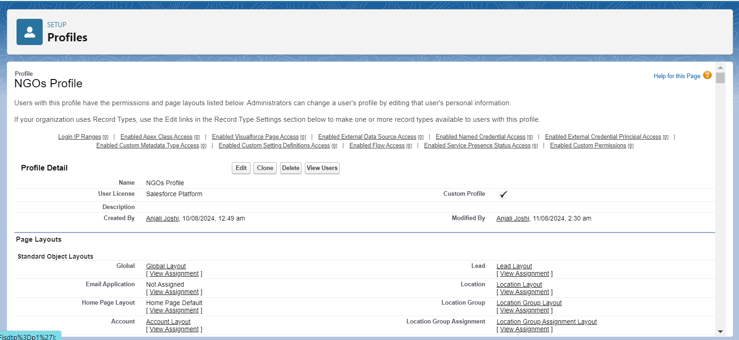

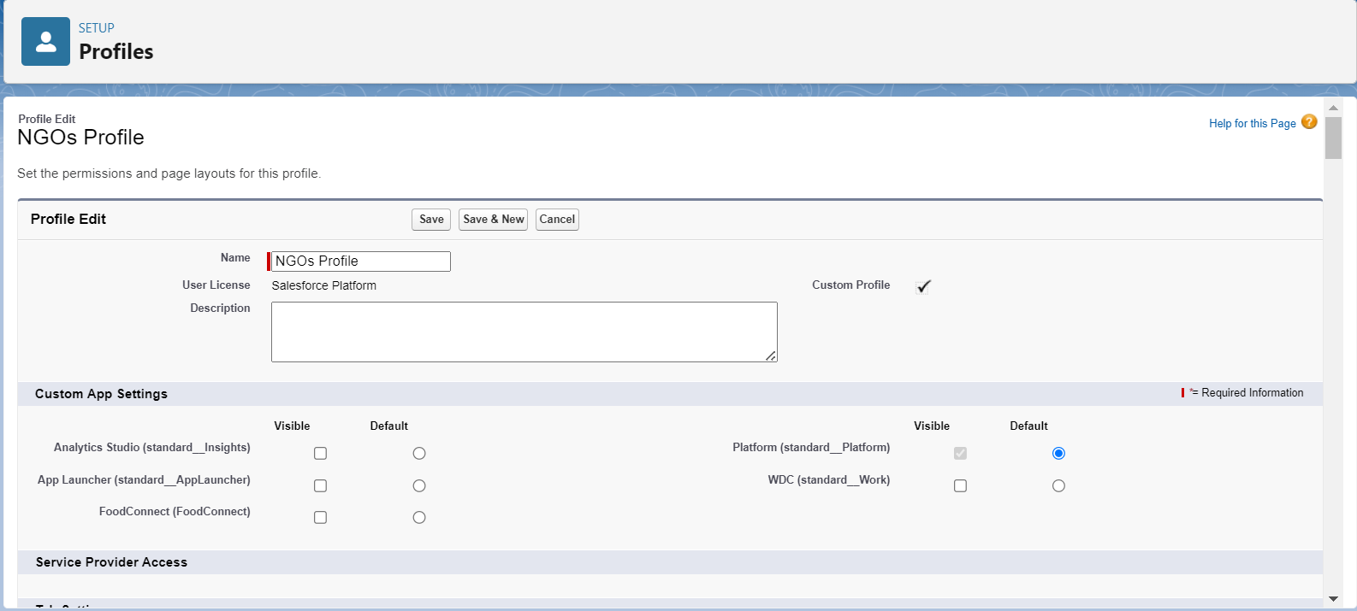

## 9. Creation Of Users

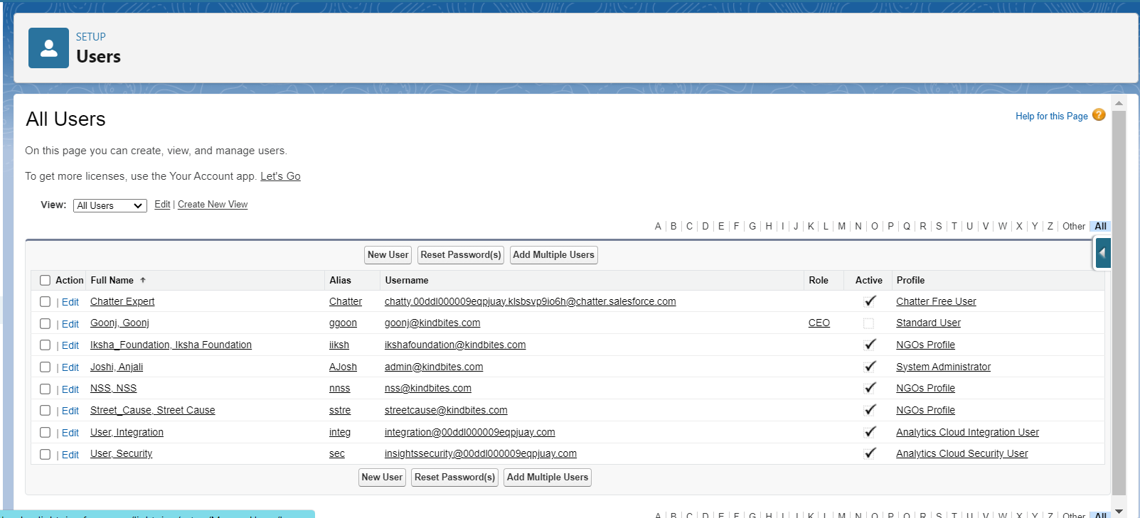

### 9.1 Creation of User1

1. Go to setup page >> type users in Quick Find bar >> click on users>> New user.
2. First Name : Iksha Foundation

Last Name :Iksha_Foundation

Alias :iiksh

Nickname : Auto Populated

User License : Salesforce Platform

Profile : NGOs Profile

Active : Check

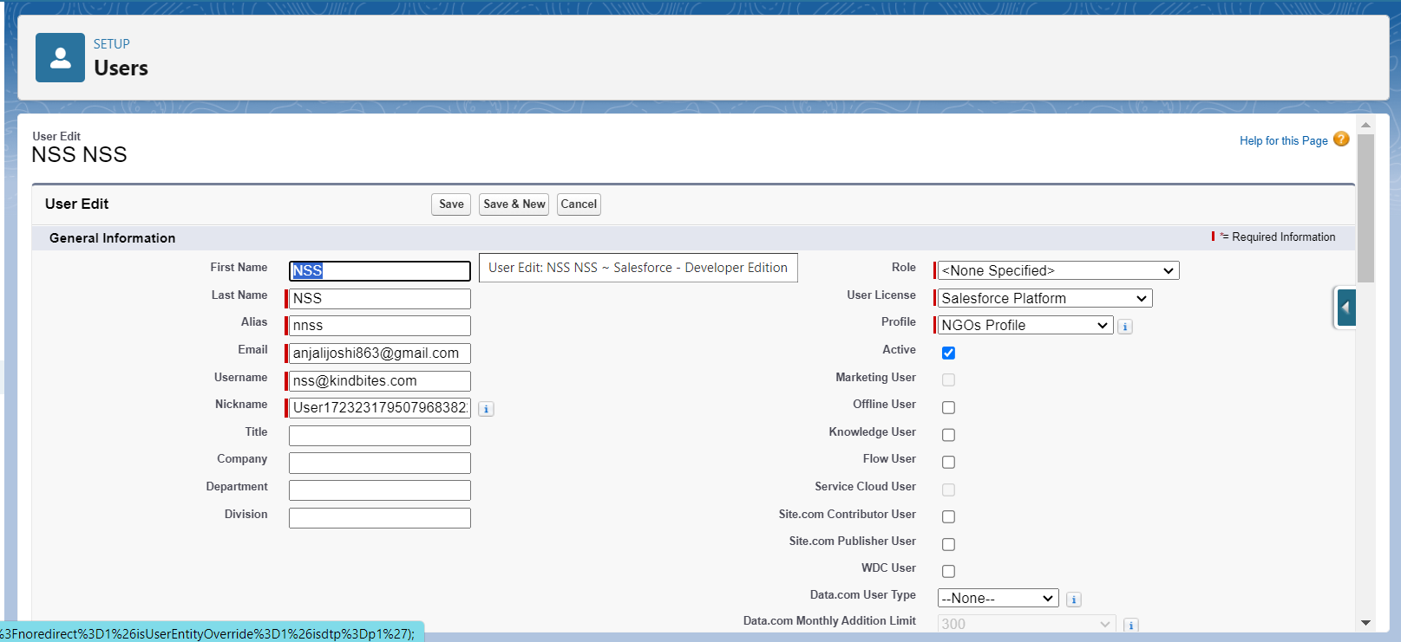

1. Click on Save

### 9.2 Creation of User2, User2

1. Create another Two Users by following steps in Activity - 1 with similar User License and Profile.
2. Give Different First Name, Last Name based on Different NGO’s.

Using above instructions, I created two more users and they are:

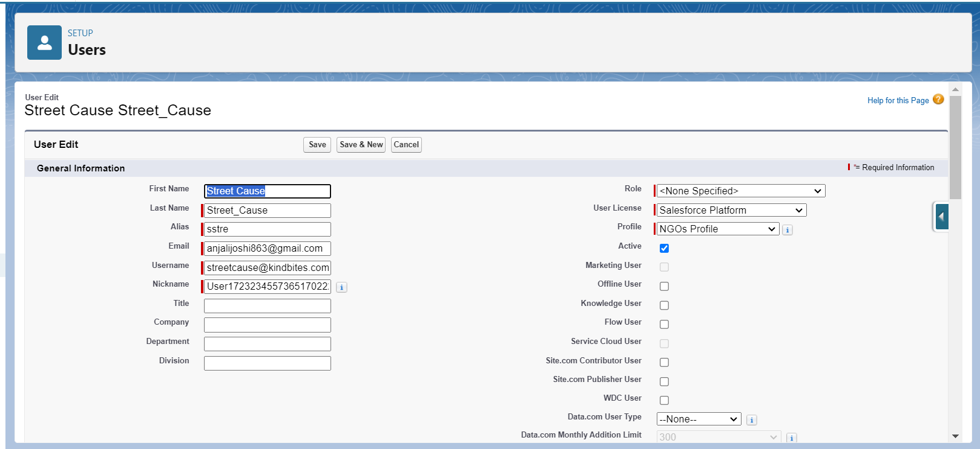

## 10.Public Groups

### 10.1 Creation of Public Group 1

1. Go to setup page  >>  type Public Groups in Quick Find bar  >>  click on Public Groups >>  click on New.
2. Under Group Information:

Label : Iksha

Group Name : Iksha

Grant Access Using Hierarchies : Check

1. In Search, Select Users.
2. In Selected Members Add Iksha Foundation and System Administrator

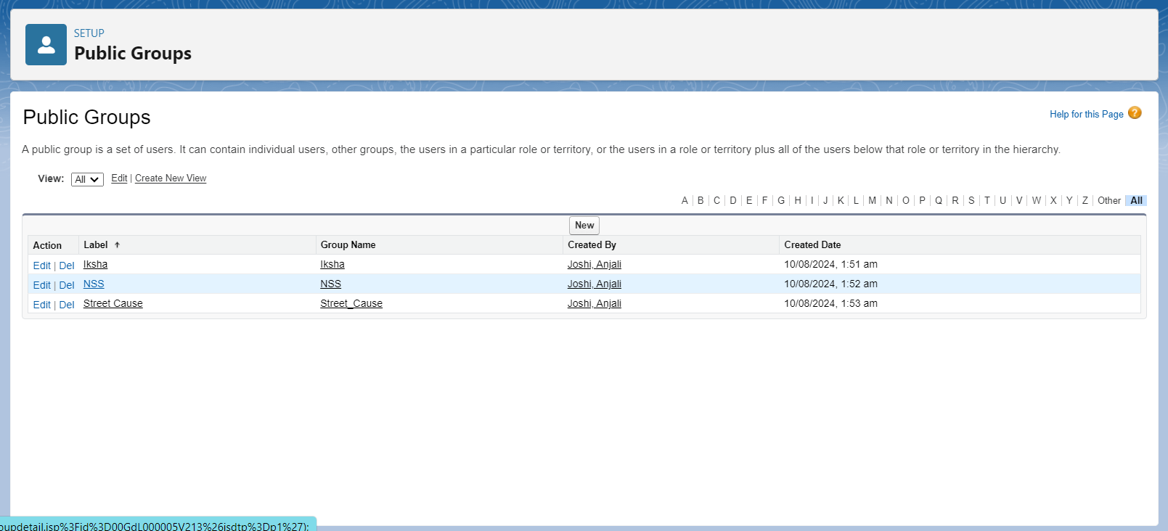

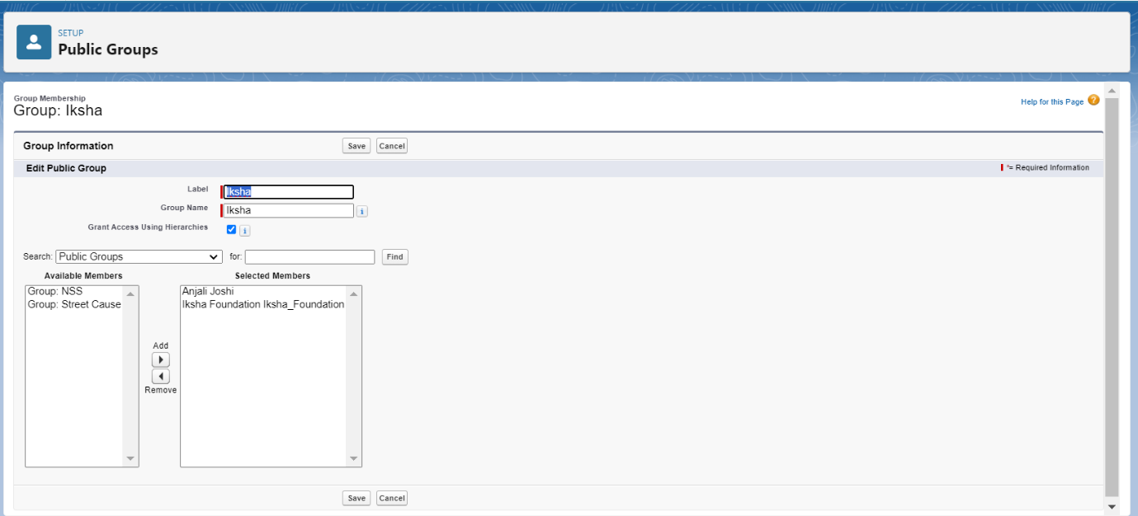

### 10.2 Creation of Public Group 2

1. By Following Steps in Activity 1, Create other two Public Groups for other two users.
2. After Saving this would look like this.

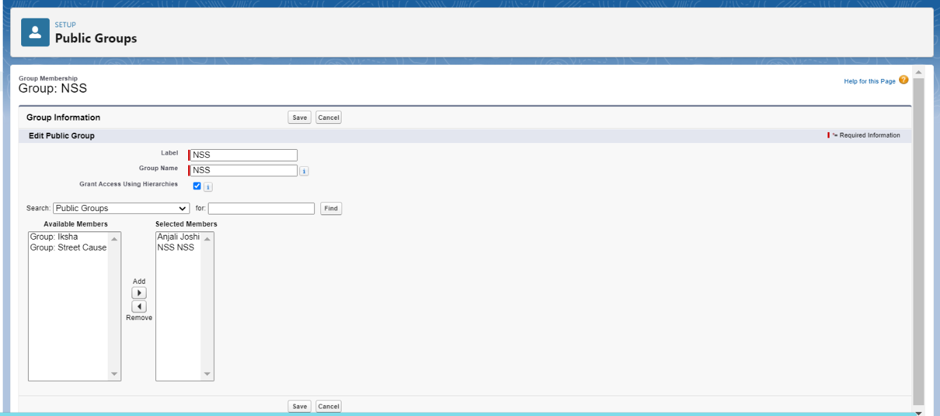

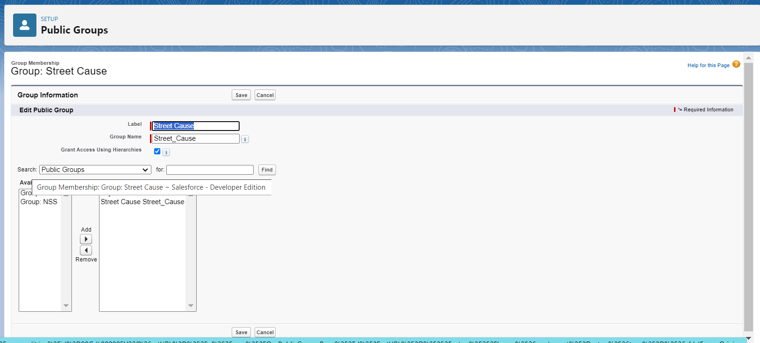

## 11.Report Types

### 11.1 Creation of Report Types

1. Go to setup page >> type Report Types in Quick Find bar >> click on Report Types >> click on Continue   >> Click on New Custom Report Type.
2. In Define the Custom Report Type:

Primary Object: Select Venues

Report Type Label: Venue with DropOff with Volunteer

Report Type Name: Venue_with_DropOff_with_Volunteer

Description: Venue with DropOff with Volunteer

Store in Category: Select Other Reports

Deployment Status: Deployed

1. Click on Next
2. Near Click to relate another Object Select Drop-Off Points.
3. And also select "A" records may or may not have related "B" records.
4. Now again Near Click to relate another Object Select Volunteers.
5. Now click on Save

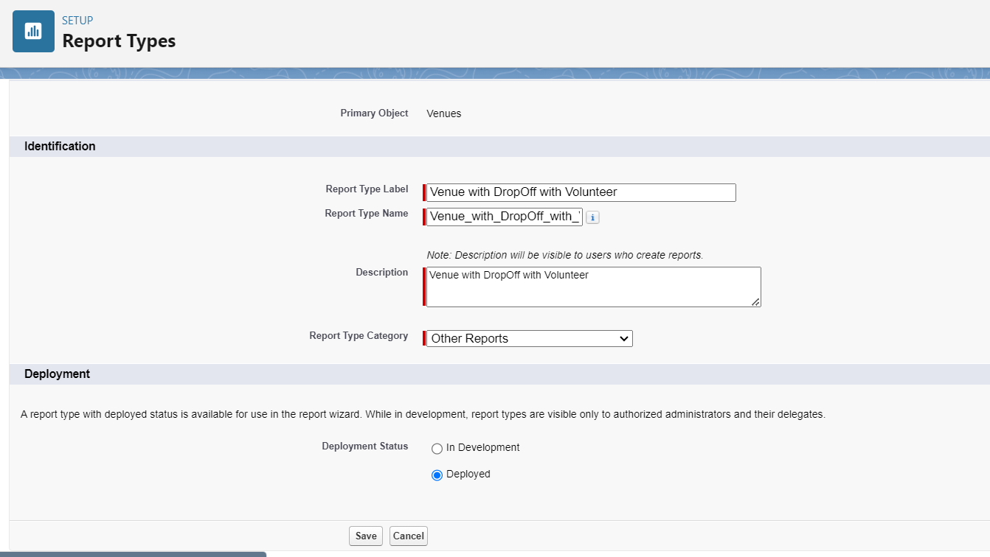

## 12. Reports

### 12.1 Creation of Report on Venue with DropOff with Volunteer

1. Go to the app (FoodConnect) >> click on the reports tab
2. Click on New Folder.

Folder Label: Custom Reports

Folder Unique Name: CustomReports

1. Open Custom Reports and click on New Report
2. Select Report Type: Venue with DropOff with Volunteer
3. Then click on Start Report.
4. In GROUP ROWS: Add Volunteer Name
5. In Columns: Add Venue Name, Drop-Off point Name, Distance.

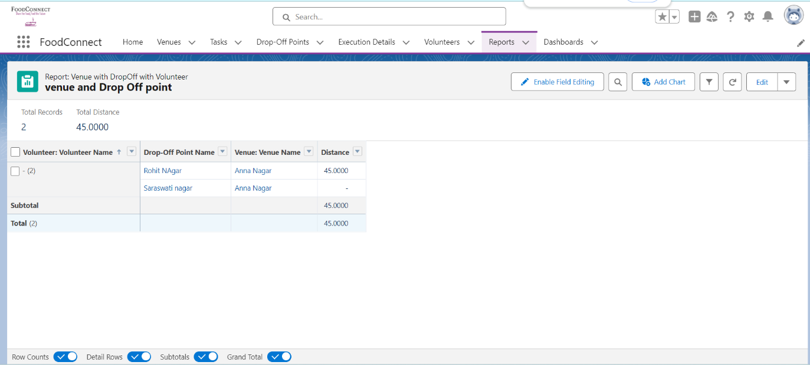

1. Now click on Save & Run.
2. Give Label as:
3. Report Name: venue and Drop Off point
4. Report Unique Name: Auto Populated
5. Click on Select Folder and select Custom Report, then click on Save.

### 12.2 Creation of Report on Volunteers with Execution Details and Tasks

1. Go to the app(FoodConnect)  >>  click on the reports tab
2. Click on Custom Reports Folder and click on New Report
3. Select Report Type : Volunteers with Execution Details and Tasks.
4. Then click on Start Report.
5. In GROUP ROWS : Volunteer ID
6. In Columns : Add Volunteer : Volunteer Name, Task : Task Name, Execution Detail : Execution Detail Name, Volunteer: Owner Name, Task: Date, Task : Rating.

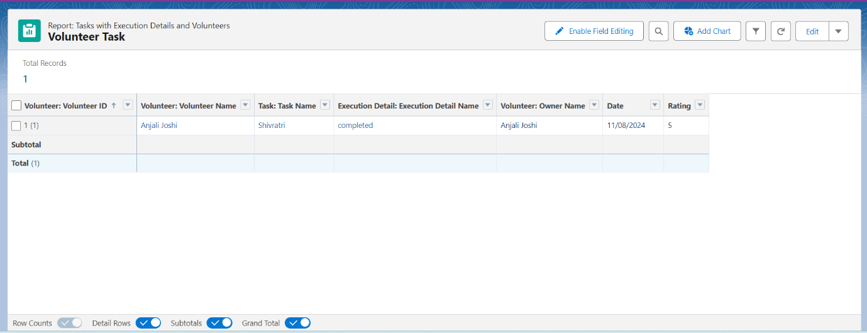

1. Now click on Save & Run.
2. Give Label as :

Report Name : Volunteer Task

Report Unique Name : Auto Populated

1. Click on Select Folder and select Custom Report, then click on Save.

## 13.Dashboards

### 13.1 Adding Venue and Drop Off Point Report to The Dashboard

1. Go to the app (FoodConnect) >> click on the Dashboards tab.
2. Click on New Folder.

Folder Label: Custom Dashboards

Folder Unique Name: Auto Populated

1. Open Custom Dashboards and click on New Dashboards
2. Name: Organization Details
3. Click on Widget and select Chart or Table
4. In Select Report: Select venue and Drop Off point Report.
5. Then click on select
6. In Add Component:

Display As: Select Lightning Table

Component Theme: Select Dark (Optional)

1. Now click on save.

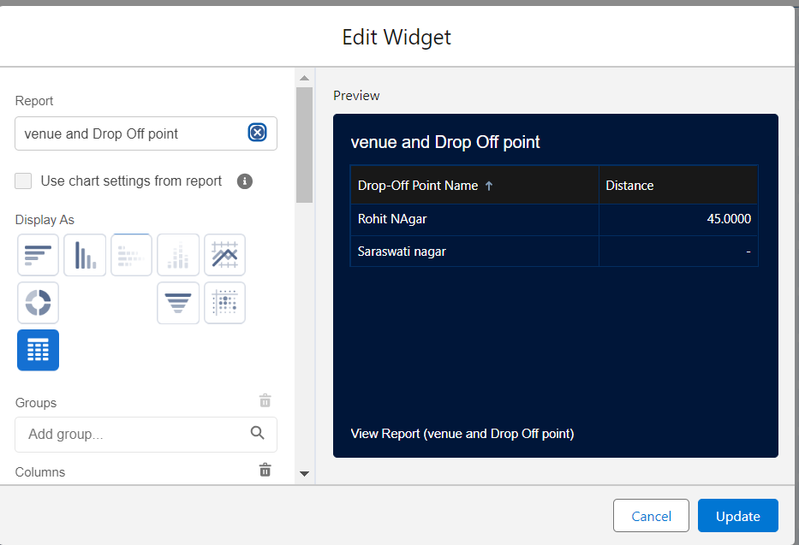

### 13.2 Adding Volunteer Task Report to The Dashboard

1. Click on Widget and select Chart or Table
2. In Select Report : Select Volunteer Task Report.
3. Then click on select
4. In Add Component:

Display As : Select Line Chart

Component Theme : Select Dark (Optional)

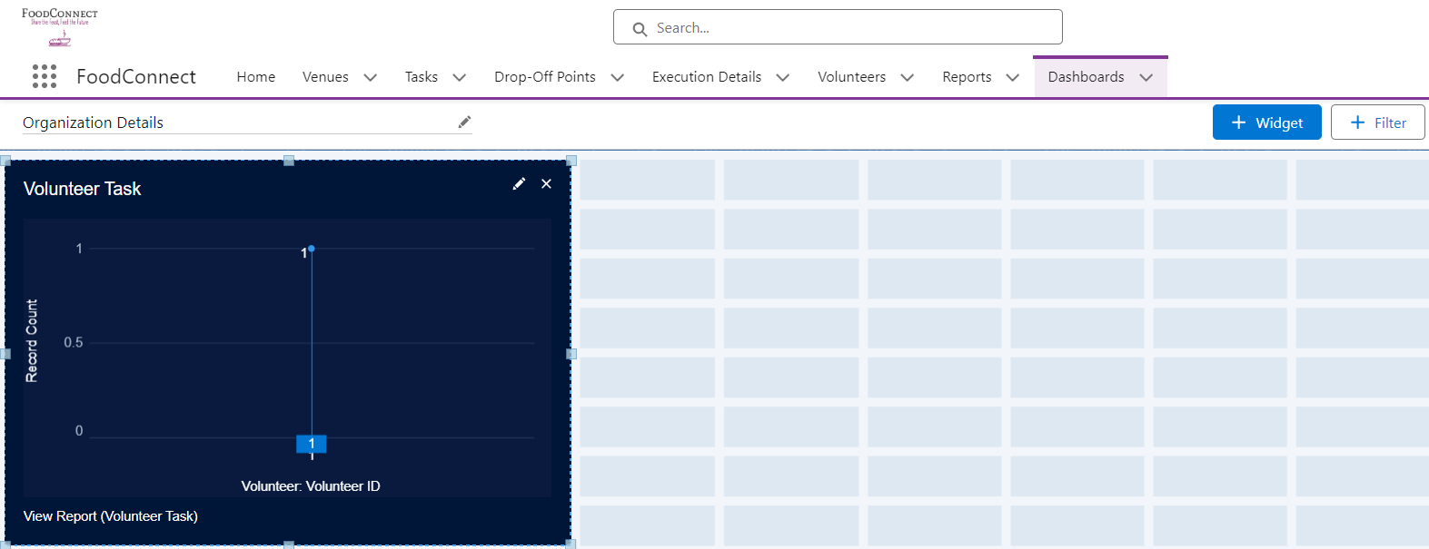

1. Now click on save.

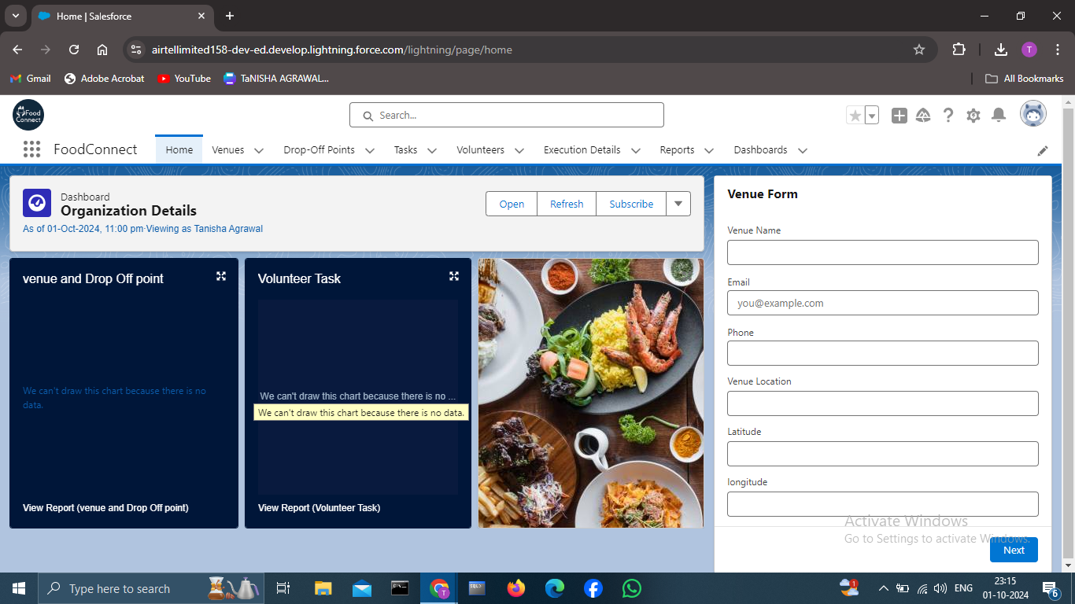

## 14. Sharing Rules

### 14.1 Creation Of Sharing Rules

1. Go to setup  >>  type Sharing Settings in quick find box  >>  Click on the Sharing Settings.
2. Scroll down and find Drop-Off point Sharing Rules.
3. Click on new near Drop-Off point Sharing Rules and Name it as:

Label : Rule 1

Rule Name : Rule_1

1. Select your rule type : Select Based on criteria.
2. Select which records to be shared:

Field : Operator : Value = Distance : less than : 15

1. Select the users to share with : Near Share With

Public Groups : Iksha

1. Click on Save.
2. Click on new near Drop-Off point Sharing Rules and Name it as:

Label : Rule 2

Rule Name : Rule_2

1. Select your rule type : Select Based on criteria.
2. Select which records to be shared:

Field : Operator : Value = Distance : greater than : 15

Field : Operator : Value = Distance : less or equal : 30

1. Select the users to share with : Near Share With

Public Groups : NSS

1. Click on Save.
2. Click on new near Drop-Off point Sharing Rules and Name it as:

Label : Rule 3

Rule Name : Rule_3

1. Select your rule type : Select Based on criteria.
2. Select which records to be shared:

Field : Operator : Value = Distance : greater than : 30

Field : Operator : Value = Distance : less or equal : 50

1. Select the users to share with : Near Share With

Public Groups : Street Cause

1. Click on Save.

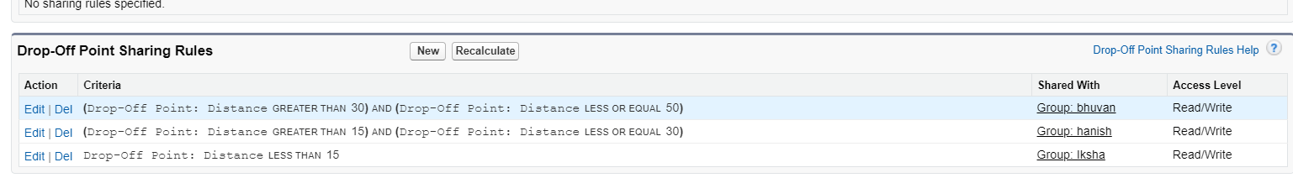

## 15.Home Page

### 15.1 Creation of Home Page

1. Go to setup >> type Lightning App Builder in quick find box  >>  Click on the Lightning App Builder and Select the New.
2. Select Home Page and give Label as HOME Page.
3. Select Standard Home Page.
4. Near Components search for Flow and Drag and Drop in Right Side Section..
5. On the right hand side:

Flow : Venue Flow

1. Near Components search for Dashboard, then Drag and Drop it in first Section.

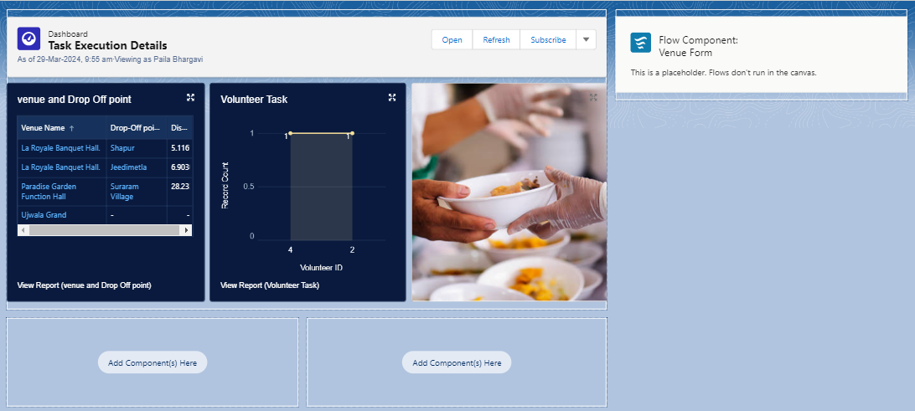

1. Click on Save and Activation, then click on App Default, then Add Assignments.
2. Add FoodConnect App and then Save.
3. FoodConnect Home Page would Look Like this.

### After Doing all the Work My Final home page looks like this



## 16. Conclusion

By leveraging the Salesforce platform, the project successfully established a streamlined and transparent system for managing surplus food donations. Through efficient coordination with volunteers and timely delivery to beneficiaries, the project effectively addressed food insecurity while maximizing the utilization of available resources.

## 